
COMSATS University Islamabad, Sahiwal Campus
Smart Basket

A project presented to
COMSATS Institute of Information Technology, Islamabad Sahiwal Campus

In partial fulfillment
of the requirement for the degree of

Bachelor of Science in Software Engineering (2022-2026)

By

Tayab Sultan CIIT/FA22-BSE-063/SWL
Talha Umar CIIT/FA22-BSE-104/SWL
Muhammad Kashif Am CIIT/FA22-BSE-111/SWL
DECLARATION

We hereby declare that this software, neither whole nor as a part, has been copied out from any source. It is further declared that we have developed this software and accompanied report entirely on the basis of our personal efforts. If any part of this project is proved to be copied out from any source or found to be reproduction of some other. We will stand by the consequences. No portion of the work presented has been submitted of any application for any other degree or qualification of this or any other university or institute of learning.

Tayab Sultan Talha Umar Muhammad Kashif Amin

CERTIFICATE OF APPROVAL
It is to certify that the final year project of BS (SE) “SMART BASKET” was developed by Tayab Sultan (CIIT/FA22-BSE-063/SWL), Talha Umar (CIIT/FA22-BSE-104/SWL)
and Muhammad Kashif Amin (CIIT/FA22-BSE-111/SWL) under the supervision of Mr. Shahzad Ali that in their opinion; it is fully adequate, in scope and quality for the degree of Bachelors of Science in Software Engineering.

Supervisor
Mr. Shahzad Ali
Lecturer
Department of Computer Science
COMSATS University Islamabad, Sahiwal Campus

Head of Department Dr. Zafar Iqbal Roy
Assistant Professor
Department of computer science
COMSATS University Islamabad, Sahiwal Campus

Executive Summary

Smart Basket is a modern mobile-based e-commerce platform developed to simplify grocery shopping, order management, and vendor–customer interaction through a secure, efficient, and user-friendly digital environment. Designed with a strong focus on convenience, real-time services, and accessibility, the platform bridges the gap between customers and local grocery vendors by providing a centralized system for browsing products, placing orders, and tracking deliveries. The application enables customers to register or log in, explore products by categories, view product details, add items to their cart, make secure payments, and monitor order status in real time.
For vendors, Smart Basket offers a dedicated dashboard that allows efficient management of business operations. Vendors can add and update product listings, manage inventory levels, receive and process incoming orders, and monitor their sales performance. The system ensures that vendors are instantly notified about new orders, enabling quick response and improved service delivery. Additionally, vendors can analyze order trends and inventory data to make informed decisions and optimize their operations.
Administrators are provided with a centralized control panel to oversee the entire platform. They can manage user accounts, monitor vendor activities, handle product listings, and ensure smooth system operations. The admin panel also supports tracking of orders, resolving disputes, and maintaining overall system integrity. This role-based architecture ensures effective communication and coordination between customers, vendors, and administrators while maintaining transparency and data consistency.
A key feature of Smart Basket is its seamless order and payment processing system, which integrates local digital payment solutions such as JazzCash and EasyPaisa. This allows users to perform secure and convenient transactions tailored to the local market. The platform also includes a real-time notification system that keeps users informed about order confirmations, payment status, and delivery updates, enhancing the overall user experience.

Acknowledgement

All praise is to Almighty Allah who bestowed upon us a minute portion of His boundless knowledge by virtue of which we were able to accomplish this challenging task.
We are greatly indebted to our project supervisor of Mr. Ali Sher Kashif and co-supervisor Dr. Fakhar Mustafa. Without their personal supervision, advice, and valuable guidance, completion of this project would have been doubtful. We are deeply thankful for their encouragement and continual support during this work.
We also extend our heartfelt gratitude to our families and friends who have been a constant source of support and motivation throughout this journey.

Tayab Sultan Talha Umar Muhammad Kashif Amin

Abbreviations

UI | User Interface
UX | User Experience
API | Application Programming Interface
SDK | Software Development Kit
DB | Database
NoSQL | Not Only SQL
FCM | Firebase Cloud Messaging
IDE | Integrated Development Environment
MVVM | Model-View-ViewModel
CRUD | Create, Read, Update, Delete
GPS | Global Positioning System
OTP | One-Time Password

Table of Contents
1 Introduction 1
1.1 Brief 1
1.1.1 Purpose of the Project 2
1.1.2 Scope of the System 3
1.1.3 Technologies Used 4
1.1.4 System Overview 8
1.1.5 Outcome of the Project 10
1.2 Relevance to Course Modules 12
1.2 Project Background 13
1.3 Literature Review 14
1.4 Analysis from Literature Review 14
1.5 Methodology and Software Lifecycle 15
1.5.1 Rationale behind Selected Methodology: 16
2 Problem Definition 18
2.1 Problem Statement 18
2.2 Deliverables and Development Requirements 19
2.2.1 Major Deliverables 19
2.2.2 Development Requirements 19
2.3 Current System 20
3 Requirement Analysis 22
3.1 Use Case Diagram 22
3.2 Use Case Description 23
3.3 Functional Requirements 32
3.3.1 Customer Registration and Login 32
3.3.2 Product Browsing and Search 32
3.3.3 Cart Management 32
3.3.4 Order Placement 32
3.3.5 Payment Processing 33
3.3.6 Real-Time Order Tracking 33
3.3.7 Vendor Inventory Management 33
3.3.8 Vendor Order Processing 33
3.3.9 Push Notification System 33
3.3.10 Vendor Dashboard and Reporting 34
3.4 Non-Functional Requirements 34
3.4.1 Performance Requirements 34
3.4.2 Scalability Requirements 34
3.4.3 Security Requirements 34
3.4.4 Usability Requirements 34
3.4.5 Reliability Requirements 35
3.4.6 Maintainability Requirements 35
3.4.7 Portability Requirements 35
3.4.8 Data Integrity Requirements 35
3.4.9 Availability Requirements 35
3.4.10 Extensibility Requirements 36
3.4.11 Backup and Recovery Requirements 36
3.4.12 Load Handling Requirements 36
4 Design and Architecture 38
4.1 System Architecture 38
4.3 Process Flow/Representation 41
4.3.1 Activity Diagrams 41
4.3.1.1 Customer: Browsing Products and Placing Order 42
4.3.1.2 Customer: Tracking Order Status 43
4.4 Design Models 46
4.4.1 Sequence Diagram 46
4.4.2 Class Diagram 50
5 Implementation 53
5.1 Algorithm 53
5.1.1 User Authentication (Login / Signup) 53
5.1.2 Add Item to Cart 54
5.1.3 Place Order 55
5.1.4 Process Payment 55
5.1.5 Update Delivery Status 56
5.1.6 Manage Inventory 57
5.1.7 Send Push Notification 58
5.1.8 View Dashboard Reports 59
5.2 External APIs 59
5.3 User Interface 61
5.3.1 Splash Screen 61
5.3.2 Login Screen 62
5.3.3 Sign-up Screen 63
5.3.4 Home Screen 64
5.3.5 Cart Screen 65
5.3.6 Tracking Screen 66
5.3.7 Order Confirmation 67
5.3.8 Checkout Screen 68
5.3.9 Favorite Items Screen 69
6 Testing and Evaluation 71
6.1.1 System Testing 71
6.1.2 Unit Testing 73
6.1.3 Functional Testing 75
6.1.4 Integration Testing 76
6.2 Tools and Technologies 77
6.3 Summary 79
7 Conclusion 81
7.1 Future Work 82
8 References 84

List of Figures
Figure 3. 1: Smart Basket Use Case Diagram 22
Figure 4. 1: Smart Basket System Architecture 39
Figure 4. 2: ER Diagram 40
Figure 4. 3: Customer: Browsing Products and Placing Order 42
Figure 4. 4: Customer: Tracking Order Status 43
Figure 4. 5: Vendor: Managing Product Inventory 44
Figure 4. 6: Vendor: Inventory Management 45
Figure 4. 7: Customer: Order Placement and Payment Process 46
Figure 4. 8: Customer: Order Tracking Process 47
Figure 4. 9: Vendor: Order Acceptance and Management 48
Figure 4. 10: Vendor: Product Inventory Sequence 49
Figure 4. 11 : Smart Basket Class Diagram 50
Figure 5. 1: Splash Screen 61
Figure 5. 2: Login Screen 62
Figure 5. 3: Sign-up screen 63
Figure 5. 4: Home Screen 64
Figure 5. 5: Cart Screen 65
Figure 5. 6: Tracking Order Screen 66
Figure 5. 7: Order Confirmation Screen 67
Figure 5. 8: Checkout Screen 68
Figure 5. 9: Favorite Screen 69

List of Tables
Table 1. 1: Technologies Used in Smart Basket 9
Table 1. 2: Relevance to Course Modules 12
Table 3. 1: User Registration and login 23
Table 3. 2: Browse Products 24
Table 3. 3: Manage Cart 25
Table 3. 4: Place Order 26
Table 3. 5: Make Payment 27
Table 3. 6: Track Order 28
Table 3. 7: Send Notification 29
Table 3. 8: Manage Inventory 30
Table 3. 9: View Dashboard Report 31
Table 5. 1: External APIs 59
Table 6. 1: System Testing Table 71
Table 6. 2: Unit Function Table 73
Table 6. 3: Functional Test Case Table 75
Table 6. 4: Integration Testing Table 76
Table 6. 5: Tools and Technologies Table 78

Chapter 1
INTRODUCTION

1 Introduction
Smart Basket is a cross-platform mobile application developed as a Final Year Project at COMSATS University Islamabad, Sahiwal Campus. It is a modern grocery shopping platform designed to bridge the gap between local grocery vendors and customers by providing a secure, user-friendly, and efficient digital shopping environment. The system enables customers to browse grocery items from vendor stores, add products to their cart, place orders, select preferred payment methods, and track deliveries in real time from the comfort of their smartphones.
Vendors are provided with a dedicated admin panel where they can manage product inventory, set and update prices, process incoming customer orders, and monitor business performance through a visual dashboard. Smart Basket operates on a dual-interface model: the Customer App and the Vendor Panel. Both interfaces are connected through a Firebase backend that ensures real-time data synchronization, secure authentication, cloud storage, and scalable serverless operations.
The application is developed using Flutter, ensuring cross-platform compatibility with both Android and iOS devices through a single codebase. Firebase services handle authentication, the Firestore real-time database, cloud storage, and push notifications via Firebase Cloud Messaging (FCM). Payment options include Cash on Delivery (COD) and digital wallet integration with JazzCash and EasyPaisa, catering to a wide range of users in Pakistan's local retail market.
Smart Basket is structured around three major user roles: Customer, Vendor, and the system-level backend. Each role interacts with a tailored set of features designed to simplify grocery operations, enhance communication, and promote digital adoption among small and medium grocery businesses. The architecture follows the MVVM pattern, ensuring modularity, testability, and long-term maintainability of the system.

1.1 Brief
Smart Basket is a cross-platform mobile grocery shopping application developed as a Final Year Project at COMSATS University Islamabad, Sahiwal Campus. The project was initiated to address the growing gap between traditional, manual grocery operations at the local vendor level and the increasing demand for digital, convenient, and real-time shopping experiences among Pakistani consumers. Smart Basket connects local grocery vendors with nearby customers through a modern, secure, and user-friendly mobile platform built using Flutter and Firebase.
The platform operates on a dual-interface model: a Customer App that allows users to browse products, manage their cart, place orders, make payments, and track deliveries in real time; and a Vendor Panel that enables store owners to manage product inventory, process incoming orders, and monitor business performance through an analytics dashboard. The system is powered by Firebase's cloud infrastructure, which provides real-time data synchronization, secure authentication, scalable storage, and automated push notifications through Firebase Cloud Messaging (FCM).
Smart Basket is designed to be lightweight, accessible, and affordable, making it particularly suitable for small and medium-sized grocery stores operating in Pakistan's local retail market. By integrating support for popular Pakistani digital payment methods such as JazzCash and EasyPaisa alongside Cash on Delivery (COD), the platform ensures broad financial accessibility. The project was developed following the Incremental Software Development Model, allowing each module to be built, tested, and integrated systematically across seven structured development phases.

1.1.1 Purpose of the Project
The primary purpose of Smart Basket is to digitalize the grocery shopping experience for customers and modernize operational management for local vendors in Pakistan. By providing a centralized, real-time mobile platform, the project aims to eliminate the inefficiencies associated with traditional, manual grocery operations and create a seamless connection between buyers and sellers.
The project serves the following core purposes:
- To provide customers with a convenient and accessible platform to browse grocery products from local stores, add items to a shopping cart, place orders, make digital payments, and track deliveries in real time without the need to physically visit stores.
- To equip local grocery vendors with a dedicated digital panel for managing product inventory, receiving and processing customer orders, updating delivery statuses, and monitoring business performance through sales reports and analytical dashboards.
- To promote digital financial inclusion by integrating multiple payment options including Cash on Delivery (COD) and local digital wallets (JazzCash and EasyPaisa), making the platform accessible to users across all economic segments in Pakistan.
- To bridge the technological gap between small grocery vendors and their digitally-connected customers by offering an affordable, easy-to-use, and low-barrier mobile solution that does not require advanced technical expertise to operate.
- To ensure secure, reliable, and real-time communication between customers and vendors by leveraging Firebase Authentication, Firestore real-time database, and Firebase Cloud Messaging (FCM) for push notifications.
In summary, Smart Basket was developed with the purpose of transforming Pakistan's local grocery retail sector by introducing a practical, scalable, and digitally empowered shopping ecosystem that benefits both customers and vendors.

1.1.2 Scope of the System
The scope of Smart Basket defines the boundaries of the system — what it includes, what it handles, and what lies outside its current implementation. The system is designed as a complete, end-to-end digital grocery management platform covering the full lifecycle of a grocery transaction, from product discovery to order delivery and payment confirmation.
Within Scope
- User Registration and Authentication: The system supports secure signup, login, and session management for two user roles — Customer and Vendor — using Firebase Authentication with email, phone number, and Google account options.
- Product Catalog Management: Vendors can add, update, and remove product listings including product name, description, category, price, stock quantity, and image. Customers can browse and search products in real time.
- Shopping Cart Management: Customers can add, update, and remove items from their cart. Cart data is synchronized in real time between the local device cache and Firebase Firestore.
- Order Placement and Management: Customers can place orders with delivery address confirmation and payment method selection. The system generates a unique order ID, saves the order to Firestore, deducts stock, and notifies the vendor.
- Payment Processing: The system supports Cash on Delivery (COD) and digital wallet payments through JazzCash and EasyPaisa. All payment transactions are recorded in Firestore with unique transaction IDs.
- Real-Time Order Tracking: Customers can track the live status of their orders through a status timeline (Order Placed, Packed, Out for Delivery, Delivered). Each status change triggers an automatic push notification.
- Push Notification System: Firebase Cloud Messaging (FCM) is used to deliver automated notifications to customers and vendors for order events, delivery updates, and promotional offers.
- Vendor Inventory Management: Vendors can manage their entire product catalog, set low-stock alerts, and monitor real-time inventory levels through the vendor panel.
- Vendor Dashboard and Reporting: Vendors have access to a business analytics dashboard displaying total sales, order counts, pending deliveries, and product performance metrics generated from Firestore data.
- Cross-Platform Mobile Support: The application is fully functional on both Android and iOS devices through a single Flutter codebase, deployed via Google Play Console.
Outside Scope
- Smart Basket does not include a web-based interface for customers or vendors. The platform is exclusively mobile-based in its current version.
- Advanced AI-based product recommendations and machine learning features are not included in the current implementation but are planned for future development.
- Barcode scanning for inventory management is outside the current scope.
- Multi-vendor cart checkout (placing a single order from multiple stores simultaneously) is not supported in this version.
- International payment gateways such as Stripe or PayPal are outside scope; only JazzCash, EasyPaisa, and COD are supported.
- Real-time in-app chat between customers and vendors is not included in the current version.

1.1.3 Technologies Used
Smart Basket was developed using a carefully selected combination of modern, industry-standard technologies chosen for their performance, cross-platform capabilities, real-time infrastructure support, and suitability for Pakistan's local grocery market. The following table provides a comprehensive overview of all technologies, frameworks, libraries, and tools used in the development of Smart Basket.
Frontend Framework
The application is developed using the Flutter SDK (Flutter 3.x with Dart 3.x), which enables cross-platform mobile app development. This allows the system to run seamlessly on both Android and iOS devices using a single codebase, reducing development time and ensuring consistency across platforms.
Programming Language
Dart (version 3.x) is used as the primary programming language for the application. It supports the implementation of business logic, user interface components, and state management, making it integral to the overall functionality of the Flutter-based system.
Backend Infrastructure
Firebase (Google) serves as the backend infrastructure, utilizing the Firebase SDK for Flutter. It provides a serverless environment that handles authentication, database management, cloud storage, and push notifications, eliminating the need for manual server maintenance.
Real-Time Database
Firebase Firestore, a NoSQL cloud database, is used for real-time data storage and synchronization. It stores critical application data such as users, products, orders, payments, and notifications, ensuring instant updates across all connected devices.
Authentication
Firebase Authentication is implemented using the Firebase Auth SDK to manage secure user login and registration. It also supports session handling and role-based access control, ensuring that different types of users (e.g., customers and vendors) have appropriate access levels.
Push Notifications
Firebase Cloud Messaging (FCM) is used to deliver automated push notifications. This includes order updates, delivery status notifications, and promotional messages, enhancing user engagement and communication.

Cloud Storage
Firebase Cloud Storage, integrated through the Firebase Storage SDK, is used to store and retrieve media files such as product images and vendor-related content securely and efficiently.
Serverless Functions
Firebase Cloud Functions, running on a Node.js environment, handle backend logic such as payment processing, stock updates, and scheduled operations. This allows scalable and event-driven execution without managing servers.
Payment Gateway
JazzCash API is integrated (via sandbox and live environments) to facilitate digital wallet payments for users in Pakistan. It enables secure and convenient transaction processing within the app.
Payment Gateway
EasyPaisa API is also integrated as an additional payment option. Like JazzCash, it supports both sandbox and live environments, providing flexibility and accessibility for local users.
Location Services
Google Maps API, used through the Maps SDK for Flutter, enables location-based features such as delivery address confirmation and nearby store detection, improving the overall user experience.
UI Design System
Material Design 3 is used via Flutter’s Material Library to ensure a consistent, modern, and responsive user interface. It provides standardized components, typography, and themes for better usability and accessibility.
Local Storage
Shared Preferences (via the shared preferences package) is used for local device storage. It helps in caching cart data, maintaining user sessions, and enabling limited offline functionality.

State Management
State management is handled using Provider or GetX packages. These tools ensure efficient communication between the UI and business logic layers, following the MVVM architecture for better scalability and maintainability.
IDE
Android Studio (Electric Eel or latest version) is used as the primary integrated development environment for Flutter development, offering robust tools for coding, debugging, and testing.
IDE
Visual Studio Code (latest version) serves as a secondary code editor. It is widely used for Dart/Flutter development and Firebase configuration due to its lightweight nature and extensive extensions.
Version Control
Git and GitHub (Git 2.x) are used for source code management. They enable version tracking, collaborative development, and efficient handling of code changes.
API Testing
Postman (latest version) is used for testing APIs, including Firebase Cloud Functions and payment gateway integrations, ensuring that all endpoints function correctly.
UI/UX Design
Figma, a web-based design tool, is used for wireframing, prototyping, and designing user interfaces for both customers and vendors, ensuring a user-friendly experience.
Testing
Firebase Test Lab provides cloud-based automated testing on virtual Android devices. It ensures the application performs well under different scenarios and device configurations.
App Deployment
Google Play Console is used for deploying and distributing the Smart Basket application to Android users. It manages app releases, updates, and performance monitoring after deployment.

1.1.4 System Overview
Smart Basket is a three-tier, cloud-powered grocery management system organized into a Presentation Layer, an Application Layer, and a Data Layer. Each tier is designed to handle a specific set of responsibilities, ensuring clean separation of concerns, efficient data flow, and reliable system performance.
Presentation Layer (Flutter UI): The topmost tier consists of the user-facing mobile interface built using Flutter and Dart. It includes two distinct interfaces: the Customer App and the Vendor Panel. The Customer App provides screens for login and registration, product browsing and search, cart management, checkout, payment, order confirmation, order tracking, and user profile management. The Vendor Panel provides screens for inventory management, incoming order processing, delivery status updates, and business performance dashboards. Both interfaces follow Material Design 3 guidelines to ensure a consistent, intuitive, and accessible user experience across Android and iOS devices.
Application Layer (Business Logic): The middle tier handles the core business logic of Smart Basket through dedicated modules implemented in Dart. Each module is responsible for a specific functional domain. The User Authentication Module manages secure login, signup, session handling, and role-based access control. The Product and Inventory Module handle product catalog operations, stock monitoring, and low-stock alerts. The Cart and Order Module manage cart operations, order creation, stock deduction, and order status tracking. The Payment Module processes COD and digital wallet payments and logs transaction records. The Notification Module dispatches push notifications via Firebase Cloud Messaging for all key system events. The Dashboard and Analytics Module aggregates Firestore data to generate sales summaries and performance metrics for vendors. The MVVM (Model-View-ViewModel) architecture pattern ensures clean separation between the UI layer and the business logic layer, improving maintainability, testability, and scalability.
Data Layer (Firebase Backend): The bottom tier consists entirely of Firebase cloud services that power Smart Basket's backend infrastructure. Firebase Firestore serves as the real-time NoSQL database, storing eight core data collections: Users, Vendors, Products, Carts, Orders, Payments, Deliveries, and Notifications. Firebase Authentication manages identity verification and secure session tokens. Firebase Cloud Storage hosts product images and vendor media. Firebase Cloud Messaging (FCM) handles push notification delivery. Firebase Cloud Functions execute serverless backend operations including payment verification and scheduled inventory tasks. All data operations use HTTPS encryption with TLS 1.3, and Firestore Security Rules enforce role-based access control to ensure data privacy and integrity.
The three layers communicate through well-defined interfaces. The Presentation Layer calls Application Layer service methods, which in turn interact with the Data Layer through Firebase SDK calls. Real-time listeners on Firestore collections ensure that data changes are reflected instantly across all connected devices without the need for manual refresh. This architecture supports up to 5,000 concurrent users with consistent performance, a 3-second maximum load time for product listings, and 99% system uptime through Firebase's cloud infrastructure.
Table 1. 1: Technologies Used in Smart Basket
Module | Role | Key Functions
User Authentication | Customer / Vendor | Registration, login, OTP verification, password reset, role-based access
Product Management | Vendor / Customer | Add, update, delete products; browse catalog; real-time stock display
Cart Management | Customer | Add/remove items, update quantities, calculate totals, sync with Firestore
Order Management | Customer / Vendor | Place orders, update statuses (Placed → Packed → Delivered), track history
Payment Processing | Customer | COD, JazzCash, EasyPaisa integration; transaction recording; payment status
Notification System | System (FCM) | Push notifications for order events, status changes, and promotions
Inventory Management | Vendor | Manage stock levels, low-stock alerts, real-time inventory sync
Dashboard & Analytics | Vendor | Sales totals, order counts, pending deliveries, product performance charts

1.1.5 Outcome of the Project
The successful development and implementation of Smart Basket produced a comprehensive, fully functional, and deployment-ready cross-platform grocery shopping application. The project achieved all of its defined objectives and delivered a complete digital grocery ecosystem tailored for Pakistan's local retail market. The following outcomes were realized upon project completion:
1. Fully Functional Cross-Platform Mobile Application: A complete, deployment-ready Smart Basket application was developed using Flutter, supporting both Android and iOS platforms through a single codebase. The application includes all planned modules — authentication, product browsing, cart management, order placement, payment processing, order tracking, notifications, vendor inventory management, and vendor dashboard reporting — fully implemented, integrated, and tested.
2. Real-Time Grocery Management System: The integration of Firebase Firestore as the backend database enabled real-time synchronization of product listings, cart data, order statuses, inventory levels, and payment records between customers and vendors. Any change made by a vendor — such as an inventory update or order status change — is immediately reflected in the customer's interface without requiring a manual page refresh.
3. Secure and Scalable User Authentication: Firebase Authentication was successfully integrated to support secure multi-method login including email, phone number, and Google account sign-in. Role-based access control ensures that customers and vendors can only access features relevant to their respective roles. The system supports up to 5,000 concurrent authenticated users.
4. Digital Payment Integration: JazzCash and EasyPaisa payment gateway APIs were successfully integrated alongside Cash on Delivery (COD), providing customers with three flexible payment options. All digital transactions are securely processed, logged with unique transaction IDs, and stored in Firestore. This significantly reduces the dependency on cash-only transactions and promotes financial inclusion.
5. Automated Push Notification System: Firebase Cloud Messaging (FCM) was fully integrated to deliver real-time push notifications to customers and vendors for all key system events including order placement, order acceptance, delivery status updates, and promotional alerts. Notifications are dispatched automatically without any manual intervention.
6. Vendor Business Intelligence Dashboard: A functional vendor analytics dashboard was developed, providing store owners with real-time business performance metrics including total sales revenue, order counts, pending deliveries, and top-performing products. Charts and summary cards generated from Firestore data allow vendors to monitor and manage their business efficiently.
7. Comprehensive Testing and Quality Assurance: All modules were thoroughly tested through manual testing, unit testing, functional testing, and integration testing. System testing confirmed that all 10 functional requirements and 12 non-functional requirements defined in the SRS were met. No critical bugs were found in production-ready testing, and all identified issues were resolved before final submission.
8. Academic and Technical Learning Outcomes: The project successfully demonstrated practical application of key computer science concepts including object-oriented programming, database design, software engineering methodologies, mobile application development, UI/UX design principles, cloud computing, and information security. The development process reinforced the importance of structured requirement analysis, systematic design, iterative implementation, and rigorous testing in delivering a production-quality software system.
In conclusion, Smart Basket successfully delivered on its promise to modernize grocery shopping and vendor management at the local level in Pakistan. The project produced a stable, scalable, secure, and user-friendly digital platform that bridges the gap between traditional grocery retail and modern digital commerce. It serves as a strong foundation for future enhancements including AI-based product recommendations, barcode scanning, expanded payment gateways, and real-time customer-vendor chat features.

1.2 Relevance to Course Modules
The development of Smart Basket integrates multiple concepts, theories, and technical skills acquired throughout the Bachelor of Science in Computer Science (BSCS) degree program. The project combines areas such as software engineering, database management, mobile application development, and human-computer interaction to build a comprehensive and functional grocery management platform.
Table 1. 2: Relevance to Course Modules
Course Module | Application in StayBnB
Software Engineering | Prepared SRS and SDD documents, designed UML diagrams including use case, class, sequence, and activity diagrams.
Database Systems | Designed and implemented data storage using Firebase Firestore as a real-time NoSQL cloud database for users, vendors, products, orders, and transactions.
Mobile Application Development | Built cross-platform mobile interfaces using Flutter SDK and Dart, ensuring responsive UI and smooth performance on Android and iOS.
Human-Computer Interaction (HCI) | Applied UI/UX design principles using Material Design 3 to enhance user engagement, accessibility, and ease of navigation.
Information Security | Implemented Firebase Authentication, HTTPS/TLS encryption, role-based access control, and Firestore Security Rules to protect data and prevent unauthorized access.
Object-Oriented Programming | Modeled core system entities (User, Vendor, Product, Cart, Order, Payment) as OOP classes with defined attributes and methods.
Table 1.1.1: Relevance to Course Module outlines the project not only reinforces theoretical understanding but also demonstrates practical implementation of interdisciplinary knowledge, aligning with the academic objectives of the Computer Science curriculum.
By integrating these subjects, the project provides a comprehensive demonstration of real-world application of the theoretical learning gained over eight semesters.

1.2 Project Background
The grocery retail sector in Pakistan, particularly at the local and community level, still operates largely through manual and traditional methods. Customers visit physical stores, manually compare prices, and place orders verbally, while vendors maintain paper-based inventory records and struggle to efficiently manage stock, sales, and deliveries. This gap between traditional operations and growing digital consumer expectations has created a clear need for an accessible and affordable technology solution.
Existing grocery platforms such as Daraz Mart and Instacart primarily focus on large-scale retailers and urban markets, often involving high vendor fees and complex onboarding processes that make them unsuitable for small, independent grocery stores. Community vendors lack the tools to manage their business digitally, while customers lack a convenient platform to shop from their local neighborhood stores online.
Smart Basket was developed in response to these identified challenges. The project aims to offer small and medium grocery vendors a low-cost digital solution that enables them to list products, manage inventory, and process orders efficiently. At the same time, it provides customers with a convenient platform to browse products from local stores, place orders, track deliveries, and make payments digitally. By focusing specifically on Pakistan's local grocery ecosystem and leveraging Flutter and Firebase, Smart Basket delivers an accessible, real-time, and cost-effective solution that promotes digital transformation at the community level.

1.3 Literature Review
The integration of mobile technology and cloud-based backend services in grocery retail has grown significantly in recent years. Existing grocery applications such as Instacart, DarazMart, and Grocery Delivery E-commerce applications offer online product browsing, cart management, and order placement features; however, many of these platforms focus primarily on large retailers and fail to address the specific needs of small, community-level grocery vendors, particularly in developing markets such as Pakistan.
Research studies highlight the growing importance of digital platforms in local retail ecosystems. The study "Mobile Commerce and Small Retail Businesses" (Ahmed & Raza, 2021) emphasizes how mobile applications can significantly reduce operational costs and improve customer reach for small vendors. Another work, "Real-Time Database Systems for Mobile Applications" (Khan et al., 2022), demonstrates the effectiveness of Firebase Firestore in enabling real-time data synchronization between vendors and customers with minimal infrastructure costs.
Despite these advancements, many localized grocery systems still rely on manual inventory management, paper-based order tracking, and cash-only payment methods. Existing platforms often lack real-time synchronization, integrated push notification systems, and accessible digital payment options suitable for local markets. Moreover, cross-platform mobile development frameworks such as Flutter, which enable development of both Android and iOS applications from a single codebase, are underutilized in the local grocery retail segment.

1.4 Analysis from Literature Review
The literature review demonstrates that incorporating mobile technology and real-time cloud infrastructure into local grocery retail significantly improves operational efficiency, customer satisfaction, and vendor productivity. While existing platforms provide essential functionalities such as product browsing and order placement, most solutions remain limited in terms of vendor accessibility, real-time synchronization, and localized payment integration.
This analysis highlights the need for a unified grocery platform that integrates real-time inventory management, order tracking, digital payment options, and push notifications into a single, affordable, and easy-to-use mobile application targeted at small and medium grocery vendors.
1.4.1 Key Findings
The review identifies a technological gap between existing large-scale grocery platforms and the needs of small local vendors in Pakistan. Current trends show that customers expect real-time product availability, convenient order placement, and digital payment options. Vendors require simple tools for inventory management, order processing, and performance monitoring. Systems that combine role-based panels, real-time synchronization, and integrated notification services tend to achieve better usability and vendor adoption. Furthermore, cross-platform frameworks like Flutter reduce development costs and improve deployment consistency across Android and iOS devices.
1.4.2 Conceptualization of Smart Basket
Based on these findings, Smart Basket was conceptualized as a complete digital grocery ecosystem tailored for local Pakistani markets. Instead of functioning as a basic product listing app, Smart Basket integrates real-time inventory management, order tracking, digital payment processing, push notifications, and a vendor analytics dashboard. The platform provides two role-based interfaces — Customer App and Vendor Panel — each designed to handle specific grocery operations efficiently. This approach ensures improved communication, accurate inventory management, and a more reliable and convenient shopping experience for both customers and vendors. Smart Basket aims to deliver a modern, scalable, and user-friendly solution that addresses the limitations identified in existing grocery platforms.

1.5 Methodology and Software Lifecycle
The Incremental Software Development Model (Agile-Inspired) was adopted for the Smart Basket project to ensure flexibility, iterative development, and continuous improvement. This model was selected because the grocery platform consists of distinct, independently developable modules such as User Authentication, Product Management, Cart Management, Order Processing, Payment Integration, Notification System, Inventory Management, and Dashboard Reporting. The incremental approach allows each module to be developed, tested, and integrated systematically without disrupting the rest of the system.

Key Phases:
- Requirement Gathering: Identification of functional and non-functional requirements including customer registration, vendor inventory management, order placement, real-time delivery tracking, push notifications, and digital payment integration.
- System Design: Creation of system architecture, Firebase database schema, UML diagrams (use case, class, sequence, activity, state transition, and data flow diagrams), and Flutter UI wireframes for both customer and vendor interfaces.
- Implementation: Development of the Flutter frontend with Dart, while backend logic, authentication, and database operations were handled through Firebase services including Firestore, Authentication, Cloud Storage, and Cloud Messaging.
- Integration of Services: Integration of Firebase Cloud Messaging for notifications, Google Maps API for location services, and JazzCash/EasyPaisa payment gateways for digital transactions.
- Testing and Validation: Unit testing, integration testing, functional testing, and system testing were performed across all modules to ensure functionality, reliability, and performance.
- Deployment: Deployment of the Flutter application through Google Play Console, ensuring accessibility, scalability, and availability for both customers and vendors.
- Maintenance: Continuous monitoring, bug fixing, feature enhancement, and performance optimization to maintain long-term system reliability.

1.5.1 Rationale behind Selected Methodology:
The Incremental Model was selected due to its iterative development approach, which supports continuous improvement and flexible requirement handling. Unlike the traditional Waterfall model, the incremental approach allows parallel development of independent modules such as authentication, cart management, order processing, and notification systems. This flexibility is particularly important for Smart Basket, where multiple components must be integrated and tested simultaneously. The model also encourages regular testing and feedback, ensuring that the final system remains scalable, reliable, and aligned with both customer and vendor requirements.

Chapter 2
PROBLEM DEFINITION

2 Problem Definition
The local grocery retail sector in Pakistan faces significant operational challenges driven by manual processes, limited digital adoption, and the absence of integrated technology solutions accessible to small and medium-sized vendors. While e-commerce has grown globally, community-level grocery stores continue to operate through traditional methods, resulting in inefficiencies in inventory management, order processing, and customer communication. The Smart Basket project was initiated to address these challenges by introducing a mobile-based grocery platform that connects local vendors with nearby customers through a simple, efficient, and affordable digital solution.

2.1 Problem Statement
Traditional grocery shopping in Pakistan remains predominantly manual, with customers physically visiting stores to browse and purchase products. Local grocery vendors maintain paper-based inventory records and rely on word-of-mouth communication for order management, leading to frequent stock mismatches, delayed order fulfillment, and poor customer experience. Furthermore, existing digital grocery platforms are largely designed for large retailers and are inaccessible to small, independent vendors due to high operational costs and complex onboarding requirements.
A deeper analysis highlights several critical issues. Vendors lack affordable tools for real-time inventory management, automated order processing, and customer communication. Customers have no digital platform to browse products from local stores, track orders, or make cashless payments conveniently. Most existing apps do not support integration with local payment gateways such as Jazz Cash and EasyPaisa, which are widely used in Pakistan. Push notification systems for order updates, delivery alerts, and promotions are largely absent in local grocery solutions.
Smart Basket addresses these challenges by providing a centralized, real-time, and user-friendly mobile platform where customers can shop conveniently from local stores and vendors can manage their operations digitally with minimal technical expertise.

2.2 Deliverables and Development Requirements
The Smart Basket project aims to deliver a complete, fully functional cross-platform grocery shopping application with role-based access, real-time inventory management, order tracking, and digital payment integration.

2.2.1 Major Deliverables
2.2.1.1 Cross-Platform Mobile Application – enabling customers to browse products, place orders, make payments, and track deliveries in real time.
2.2.1.2 Customer App – allowing users to register, browse grocery products by category, manage their cart, place orders, and view order history.
2.2.1.3 Vendor Admin Panel – enabling vendors to manage product inventory, update prices, process incoming orders, and monitor business performance through a sales dashboard.
2.2.1.4 Secure Authentication System – implementing Firebase Authentication with role-based access control for customers and vendors.
2.2.1.5 Real-Time Order Tracking – live order status updates (Order Placed, Packed, Out for Delivery, Delivered) using Firebase Firestore.
2.2.1.6 Push Notification System – Firebase Cloud Messaging (FCM) for order confirmations, delivery updates, and promotional alerts.
2.2.1.7 Digital Payment Integration – support for Cash on Delivery (COD) and local digital wallets (JazzCash and EasyPaisa).
2.2.1.8 Inventory Management System – real-time stock monitoring with low-stock alerts and auto-update after each sale.
2.2.1.9 Technical Documentation and Source Code Repository – ensuring maintainability and development transparency.

2.2.2 Development Requirements
2.2.2.1 Frontend: Flutter SDK (Dart), Material Design 3
2.2.2.2 Backend: Firebase Cloud Functions (Serverless)
2.2.2.3 Database: Firebase Firestore (NoSQL, Real-Time)
2.2.2.4 Authentication: Firebase Authentication (Email/Phone/Google)
2.2.2.5 Notifications: Firebase Cloud Messaging (FCM)
2.2.2.6 Payment Integration: JazzCash / EasyPaisa APIs (Sandbox)
2.2.2.7 Maps Integration: Google Maps API
2.2.2.8 Deployment: Google Play Console (Android)
2.2.2.9 Tools: Git, Android Studio, Visual Studio Code, Firebase Console, Postman, Figma

2.3 Current System
In the current scenario, most local grocery stores in Pakistan operate entirely through manual processes. Customers physically visit stores, verbally communicate their requirements, and receive paper receipts for their purchases. Vendors maintain handwritten inventory logs and manually track incoming orders without any digital assistance. This approach results in frequent inventory discrepancies, delayed order fulfillment, poor customer communication, and an inability to scale business operations efficiently.
Existing grocery applications in the Pakistani market, such as DarazMart, primarily serve large retailers and offer limited support for small community vendors. These platforms often involve significant fees, complex setup processes, and features that are far beyond the operational needs and technical capabilities of small grocery store owners. As a result, the majority of local vendors remain digitally excluded.
Another critical limitation of current systems is the absence of real-time order tracking and automated push notifications. Customers have no way to monitor the status of their orders after placement, which leads to uncertainty and reduced satisfaction. Furthermore, many platforms lack integration with widely-used local payment gateways such as JazzCash and EasyPaisa, forcing customers to rely exclusively on cash-based transactions.
Smart Basket overcomes these limitations by providing a fully integrated, affordable, and easy-to-use mobile application specifically designed for Pakistan's local grocery retail sector. The system offers real-time inventory management, order tracking, push notifications, digital payment support, and a vendor analytics dashboard, all within a single cross-platform application built with Flutter and Firebase.

Chapter 3
REQUIREMENT ANALYSIS

3 Requirement Analysis
Requirement Analysis, also known as Requirement Engineering, is the process of defining user expectations for a new software system to be built or modified. It involves gathering, analyzing, documenting, validating, and managing the needs and conditions required to meet stakeholder expectations, ensuring alignment with project goals. For Smart Basket, requirement analysis was conducted through stakeholder interviews with potential customers and local grocery vendors, review of existing grocery applications, and analysis of common pain points in Pakistan's local retail sector.

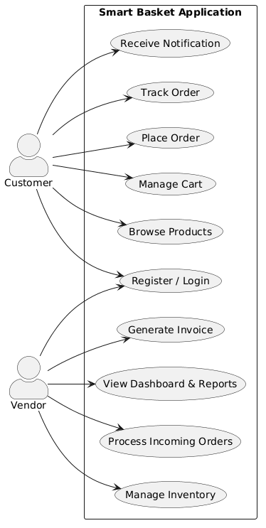
3.1 Use Case Diagram

Figure 3. 1: Smart Basket Use Case Diagram

3.2 Use Case Description
Table 3. 1: User Registration and login
Use Case ID | UC#1
Use Case Name | Register / Login
Description | Allows customers and vendors to create an account or log in to the Smart Basket system using email, phone number, or Google account credentials.
Primary Actor | Customer / Vendor
Secondary Actor | Firebase Authentication
Pre-Condition | User must have internet access and a valid email address or phone number.
Post-Condition | User is authenticated and granted access to their respective dashboard (Customer App or Vendor Panel).
Basic Flow | 1. User navigates to the login/signup screen.  2. User enters credentials (email/password) or uses Google sign-in.  3. System validates credentials via Firebase Authentication.  4. User is redirected to the appropriate dashboard based on their role.
Alternate Flow | a. User enters incorrect credentials → System displays an error message. b. User forgets password → System sends a password reset link via email.

Table 3. 2: Browse Products
Use Case ID | UC#2
Use Case Name | Browse Products
Description | Allows customers to explore available grocery products by category, search by name, and view product details including price, stock, and vendor information.
Primary Actor | Customer
Secondary Actor | Firebase Firestore
Pre-Condition | Customer must be logged in and have an active internet connection.
Post-Condition | Customer sees a list of available products matching their browsing or search criteria.
Basic Flow | 1. Customer opens the Home screen.  2. System loads product listings from Firestore.  3. Customer browses by category or uses the search bar.  4. System displays products with name, image, price, and availability.
Alternate Flow | a. No products found → System displays a 'No products available' message.  b. Network unavailable → System displays cached products from previous session.

Table 3. 3: Manage Cart
Use Case ID | UC#3
Use Case Name | Manage Cart
Description | Allows customers to add products to their cart, update quantities, remove items, and view the total cart value before proceeding to checkout.
Primary Actor | Customer
Secondary Actor | Firebase Firestore, Shared Preferences (local cache)
Pre-Condition | Customer must be logged in and at least one product must be selected.
Post-Condition | Cart is updated with selected items and the total price is recalculated.
Basic Flow | 1. Customer selects a product and taps 'Add to Cart'.  2. System adds the item and updates the cart total.  3. Customer can modify quantity or remove items.  4. Cart data is synced to Firestore and cached locally.
Alternate Flow | a. Item goes out of stock → System removes the item and notifies the customer.  b. Network unavailable → Cart is saved locally and synced when connection is restored.

Table 3. 4: Place Order
Use Case ID | UC#4
Use Case Name | Place Order
Description | The customer places an order by confirming cart items, selecting a delivery address, and choosing a payment method. The system creates an order record, notifies the vendor, and generates a unique order ID.
Primary Actor | Customer
Secondary Actor | Vendor, Firebase Firestore, Notification System
Pre-Condition | Customer must be logged in. Cart must contain at least one item. Vendor store must be active.
Post-Condition | Order is successfully created in Firestore. Vendor receives a push notification. Order ID is generated and displayed to the customer.
Basic Flow | 1. Customer proceeds to checkout from the cart screen.  2. System verifies stock availability and calculates the total cost.  3. Customer confirms delivery address and selects a payment method.  4. System generates a unique order ID and saves it to Firestore.  5. Push notifications are sent to both the vendor and the customer.
Alternate Flow | a. Item out of stock → System alerts customer and removes unavailable items.  b. Network failure → Order stored locally and synced when connection is restored.

Table 3. 5: Make Payment
Use Case ID | UC#5
Use Case Name | Make Payment
Description | The customer completes order payment through Cash on Delivery (COD) or digital wallet options (JazzCash/EasyPaisa). The system verifies and records the transaction securely.
Primary Actor | Customer
Secondary Actor | Vendor, Firebase Firestore, Payment Gateway (JazzCash/EasyPaisa)
Pre-Condition | Customer must be logged in. Order must be placed successfully. A valid payment method must be selected.
Post-Condition | Payment details stored in Firestore. Vendor notified of successful payment. Order status updated to 'Paid'.
Basic Flow | 1. Customer selects payment method (COD or digital wallet).  2. System verifies payment details.  3. Transaction is processed and logged in Firebase.  4. Confirmation message displayed to both customer and vendor.
Alternate Flow | a. Payment fails → System notifies the user and allows retry or switch to COD.  b. Gateway timeout → Transaction flagged as pending until confirmed.

Table 3. 6: Track Order
Use Case ID | UC#6
Use Case Name | Track Order
Description | The customer tracks the real-time status of an active order. The system displays order progress updates (Order Placed, Packed, Out for Delivery, Delivered) using live Firebase data.
Primary Actor | Customer
Secondary Actor | Vendor, Firebase Firestore, Notification System
Pre-Condition | Customer must be logged in. At least one active order must exist in Firestore.
Post-Condition | Latest order status is displayed to the customer. Push notifications are triggered on each status change.
Basic Flow | 1. Customer navigates to 'My Orders'.  2. Customer selects an active order.  3. System retrieves the latest order status from Firestore.  4. Status timeline is displayed (Order Placed → Out for Delivery → Delivered).
Alternate Flow | a. Order cancelled by vendor → Status updated to 'Cancelled' and customer notified.  b. Network unavailable → Cached order details displayed until connection is restored.

Table 3. 7: Send Notification
Use Case ID | UC#7
Use Case Name | Send Notification
Description | The system automatically sends push notifications to customers and vendors for important events such as order placement, status updates, promotions, and low-stock alerts.
Primary Actor | System (Firebase Cloud Messaging)
Secondary Actor | Customer, Vendor
Pre-Condition | User must be registered and logged in. Notification permissions must be granted.
Post-Condition | Notification delivered to the user device. Action link opens when notification is tapped.
Basic Flow | 1. A trigger event occurs (order confirmed, status changed, promotion added).  2. Firebase Cloud Messaging prepares the notification payload.  3. Notification is sent to the target user(s).  4. User receives the notification and views the details.
Alternate Flow | a. User has muted notifications → System logs the event for in-app view instead.  b. Network failure → System queues the notification and resends when connection is restored.

Table 3. 8: Manage Inventory
Use Case ID | UC8
Use Case Name | Manage Inventory
Description | The vendor manages product inventory by adding new products, updating quantities or prices, and removing unavailable items. Changes are synchronized in real time via Firestore.
Primary Actor | Vendor
Secondary Actor | Firebase Firestore
Pre-Condition | Vendor must be logged in. Product catalog must exist in Firestore.
Post-Condition | Updated product details are saved to Firestore. Customers see updated stock and pricing in the app.
Basic Flow | 1. Vendor logs into the vendor panel.  2. Vendor selects 'Add Product' or 'Update Product'.  3. Vendor enters product name, quantity, price, and image.  4. System validates and saves information to Firestore.  5. Confirmation message is displayed.
Alternate Flow | a. Duplicate product detected → System alerts vendor and prevents duplication.  b. Network error → Changes saved locally and synced when connection is restored.

Table 3. 9: View Dashboard Report
Use Case ID | UC#9
Use Case Name | View Dashboard Report
Description | The vendor views a summary of key business performance metrics including total sales, completed orders, pending deliveries, and customer activity through charts and reports generated from Firestore data.
Primary Actor | Vendor
Secondary Actor | Firebase Firestore
Pre-Condition | Vendor must be logged in. Transactional and order data must exist in Firestore.
Post-Condition | Dashboard displays up-to-date data visualizations. Metrics auto-refresh every 24 hours.
Basic Flow | 1. Vendor opens the 'Dashboard' section.  2. System retrieves sales, order, and inventory data from Firestore.  3. Charts and summary cards are generated.  4. Data is displayed visually for business analysis.
Alternate Flow | a. No sales data available → System displays 'No records found'.  b. Slow network → Cached data from the previous session is displayed.

3.3 Functional Requirements

Functional requirements define the specific behaviors, operations, and services that the Smart Basket platform must perform to fulfill its intended objectives. These requirements describe how the system should behave under specific conditions and how customers, vendors, and the system backend will interact with the platform.

3.3.1 Customer Registration and Login
The system shall allow customers to create an account and log in to access Smart Basket. Customers can register by providing their name, email address, password, or phone number. The system validates email format and password strength before creating the account. Registered customers are redirected to the home screen upon successful authentication. If invalid credentials are entered, the system displays appropriate error messages and allows retry. The system must support password recovery through email or OTP verification.

3.3.2 Product Browsing and Search
The system shall enable customers to browse grocery products by category and search by product name or keyword. When a customer browses or searches, the system retrieves matching products from Firestore and displays them with product images, prices, stock levels, and vendor information. If no matching products are found, the system notifies the customer. The system must support real-time product updates from vendor-managed listings.

3.3.3 Cart Management
The system shall allow customers to add, remove, and update items in their shopping cart. When a customer adds a product, the system updates the cart total and syncs data between the local cache and Firestore. Cart contents persist across sessions. The system must validate product availability before confirming cart additions and notify customers if an item goes out of stock.

3.3.4 Order Placement
The system shall allow customers to place orders by confirming cart items, selecting a delivery address, and choosing a payment method. The system creates a unique order record in Firestore, triggers vendor notifications, and updates order history for the customer. If a product becomes unavailable during checkout, the system alerts the customer and removes the item before order confirmation.

3.3.5 Payment Processing
The system shall process payments through Cash on Delivery (COD) and digital wallet options (JazzCash and EasyPaisa). The system verifies payment details, records the transaction in Firestore, updates the order status to 'Paid', and notifies the vendor. If a payment fails, the system allows retry or switching to COD. All online payments must include unique transaction IDs.

3.3.6 Real-Time Order Tracking
The system shall provide customers with real-time order tracking. After placing an order, customers can view the current status of their order through a status timeline (Order Placed, Packed, Out for Delivery, Delivered). The system retrieves live status updates from Firestore and triggers push notifications on each status change. If the network is unavailable, the system displays the last cached order status.

3.3.7 Vendor Inventory Management
The system shall allow vendors to add, update, and delete product listings from the vendor panel. Vendors can set product names, descriptions, prices, stock quantities, and images. The system validates all inputs and synchronizes inventory changes in real time with customer-facing product listings. Low-stock alerts are automatically triggered when inventory falls below a defined threshold.

3.3.8 Vendor Order Processing
The system shall allow vendors to receive, review, accept, and update order statuses. Vendors receive push notifications for new orders and can update the order status from 'Accepted' to 'Packed', 'Dispatched', and 'Delivered'. The system synchronizes status updates in real time between the vendor panel and the customer app.

3.3.9 Push Notification System
The system shall send automated push notifications via Firebase Cloud Messaging (FCM) for events including order placement, order status changes, payment confirmation, and promotional offers. Notifications must include a title, message body, timestamp, and action link. Promotional notifications can only be sent between 9 a.m. and 9 p.m.

3.3.10 Vendor Dashboard and Reporting
The system shall provide vendors with a business analytics dashboard displaying key metrics including total sales, completed orders, pending deliveries, and product performance. The dashboard retrieves data from Firestore and presents it through charts and summary cards. The dashboard auto-refreshes every 24 hours and is accessible only to authenticated vendor accounts.

3.4 Non-Functional Requirements
Non-functional requirements define the quality attributes and performance standards that Smart Basket must meet to ensure a reliable, secure, and efficient user experience.

3.4.1 Performance Requirements
Smart Basket must provide fast and responsive performance for core operations. The home screen and product listings must load within 3 seconds under normal network conditions. CRUD operations such as adding or updating inventory must complete within 2–5 seconds. Order placement and confirmation must finish within 8 seconds. Firebase real-time synchronization ensures instant updates between customers and vendors.

3.4.2 Scalability Requirements
The system must scale to support up to 5,000 concurrent users and 10,000 product listings. Firebase's cloud infrastructure enables automatic scaling based on demand without manual server configuration. As the number of vendors and customers grows, the system must continue to perform efficiently.

3.4.3 Security Requirements
Security is a critical requirement for Smart Basket as it handles personal and financial data. The system must use Firebase Authentication for secure login. All data transfers must occur over HTTPS using TLS 1.3 encryption. Firestore Security Rules must restrict database access to authenticated users. Passwords must be at least 8 characters and verified through email or OTP. Daily automated backups must be performed using Firebase Cloud Storage.

3.4.4 Usability Requirements
The Smart Basket interface must be intuitive, accessible, and consistent. The design follows Material Design 3 principles with large text, high contrast, and screen reader compatibility. Navigation is structured through categorized tabs and a bottom navigation bar. Real-time notifications, feedback pop-ups, and toast messages guide users throughout their interactions.

3.4.5 Reliability Requirements
Smart Basket must maintain 99% uptime during normal operation. Error handling mechanisms must prevent app crashes during network interruptions. Firebase auto-reconnect and local persistence features ensure data availability during temporary outages. The system must recover from minor outages within 5 minutes.

3.4.6 Maintainability Requirements
The system follows the MVVM architecture for clean separation of logic from the UI. Each module is fully documented to support future developers. Firebase Crashlytics reports bugs and runtime issues automatically. Dependencies are managed through the pubspec.yaml file. Updates can be deployed through Google Play Console without disrupting existing users.

3.4.7 Portability Requirements
Smart Basket is fully compatible with Android 10 (API Level 29) and above. The Flutter framework's responsive layout adapts to various screen sizes and resolutions. The app supports data export in CSV format for inventory reports. Deployment is handled through Google Play Console for Android distribution.

3.4.8 Data Integrity Requirements
All data stored in Smart Basket, including user profiles, product listings, orders, and payment records, must remain accurate and consistent. Client-side and server-side validation prevents duplicate entries and incomplete records. Firestore transaction handling ensures consistency during order placement and inventory updates.

3.4.9 Availability Requirements
Smart Basket must be available 24/7 for order placement, browsing, and vendor management. Firebase's cloud infrastructure provides load distribution and minimal downtime. Scheduled maintenance must be communicated in advance.

3.4.10 Extensibility Requirements
The modular MVVM architecture must support future feature additions such as AI-based product recommendations, barcode scanning for inventory management, and integration with additional payment gateways without disrupting existing functionality.

3.4.11 Backup and Recovery Requirements
The system must perform daily automated backups of all critical data including user accounts, vendor profiles, product listings, order records, and payment transactions using Firebase Cloud Storage. Recovery mechanisms must restore services with minimal data loss in case of system failure.

3.4.12 Load Handling Requirements
Smart Basket must handle at least 5,000 concurrent users without noticeable delay. The platform must efficiently manage multiple simultaneous order placements and inventory updates. Firebase's scalable infrastructure supports distributed load management.

Chapter 4
DESIGN AND ARCHITECTURE

4 Design and Architecture
In the Design and Architecture phase of Smart Basket, we establish the overall structural framework of the application and define how its components interact to deliver a seamless grocery shopping experience. This phase focuses on designing intuitive user interfaces for customers and vendors, while developing a robust backend architecture that efficiently manages product data, order processing, payment handling, and real-time push notifications. The system is designed to ensure smooth communication between all modules, secure data handling, and scalable performance.

4.1 System Architecture
Smart Basket is organized into well-defined, interconnected modules where each module is responsible for a distinct aspect of the system's functionality. This modular approach allows the system to efficiently manage complex workflows including user authentication, product management, cart handling, order processing, payment integration, push notifications, inventory management, and vendor reporting. By separating responsibilities into discrete modules, Smart Basket ensures that each component can be developed, maintained, and updated independently without affecting other parts of the system.
Modules:
- User Authentication Module: Manages secure login, registration, and role-based access control using Firebase Authentication.
- Product & Inventory Module: Handles product listings, categories, prices, stock updates, and vendor-managed inventory.
- Cart & Order Module: Allows customers to add items, manage cart contents, place orders, and track order status in real time.
- Payment Module: Processes Cash on Delivery and digital wallet payments (JazzCash/EasyPaisa) securely.
- Notification Module: Sends real-time push notifications via Firebase Cloud Messaging for orders, payments, and promotions.
- Dashboard & Analytics Module: Generates vendor business performance reports, sales summaries, and inventory insights.
- Database Module: Firebase Firestore serves as the real-time NoSQL cloud database storing all system data.
Relationships Between Modules:
- Customers interact with the Authentication, Product, Cart, Order, Payment, and Notification modules.
- Vendors interact with the Authentication, Inventory, Order, Dashboard, and Notification modules.
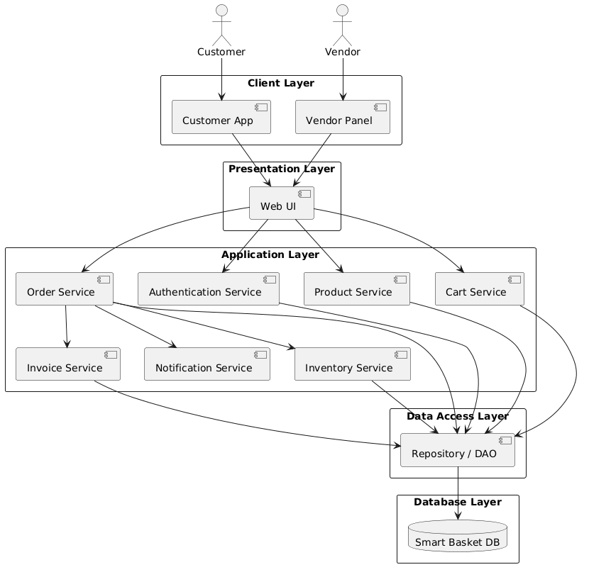
- The Dashboard & Analytics module aggregates data from all modules to provide business insights to vendors.
Figure 4. 1: Smart Basket System Architecture
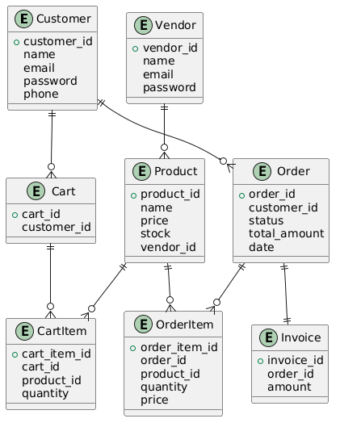
4.2.2 ER Diagram
Figure 4. 2: ER Diagram
The ER diagram illustrates the core data structure of Smart Basket, showing the main entities such as Customer, Vendor, Product, Cart, Order, invoice, CartItem, and OrderItem, along with their relationships. It highlights how customers place orders with vendors, how cart items reference products, and how each order is linked to a payment record and a delivery tracking entry. The diagram provides a clear view of how data is organized, stored, and interconnected within the Firebase Firestore database.

4.3 Process Flow/Representation
The Smart Basket system is designed to provide a smooth, efficient, and user-friendly experience for both customers and vendors through a well-structured process flow. The overall workflow begins with user authentication, where customers can either register for a new account or log in to an existing one. Once authenticated, users can easily browse a wide range of grocery products organized into different categories, making product discovery simple and intuitive. Customers can view product details, select desired items, and add them to their shopping cart.
After selecting items, users proceed to the checkout phase, where they review their cart, confirm quantities, and place orders. The system then facilitates secure payment processing through integrated payment gateways. Once the order is successfully placed, customers can track their deliveries in real time, receiving continuous updates about order status, dispatch, and expected delivery time.
On the vendor side, the system provides a dedicated interface where vendors can log in and manage their operations efficiently.

4.3.1 Activity Diagrams
Activity diagrams illustrate the sequence of steps involved in each major workflow of the Smart Basket system. They highlight key decision points such as stock availability checks, payment verification, and order confirmation, and reveal parallel processes such as vendor notification and customer order tracking updates. These diagrams improve communication between developers and stakeholders and provide a clear foundation for system implementation.
Major Process Flows:
- Customer: Browsing Products and Placing Order
- Customer: Tracking Order Status
- Vendor: Managing Product Inventory
- Vendor: Inventory Management

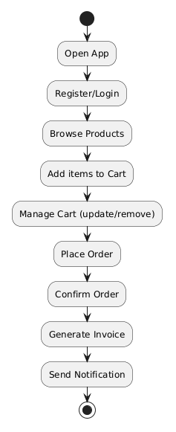
4.3.1.1 Customer: Browsing Products and Placing Order
Figure 4. 3: Customer: Browsing Products and Placing Order
Figure 4.2: This activity diagram represents the workflow followed by a customer from browsing products to successfully placing an order. The process begins with the customer logging into the app and browsing the product catalog by category. The customer selects products, adds them to the cart, and proceeds to checkout. The system verifies stock availability and calculates the total. The customer confirms the delivery address and payment method. Upon confirmation, the system creates an order record in Firestore and sends push notifications to both the customer and the vendor.

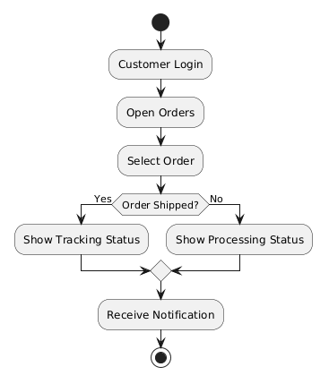
4.3.1.2 Customer: Tracking Order Status
Figure 4. 4: Customer: Tracking Order Status
Figure 4.3: This activity diagram illustrates the workflow for customers in tracking the status of their placed orders. The process begins when the customer logs into the system and opens the orders section to view their active purchases. After selecting a specific order, the system checks whether the order has been shipped. If the order has already been shipped, the customer is shown the live tracking status of the shipment. Otherwise, the system displays the current processing status of the order, such as pending, confirmed, or preparing. After viewing the relevant status information, the customer receives a notification containing the latest update regarding the selected order. The process then ends once the notification is delivered successfully.
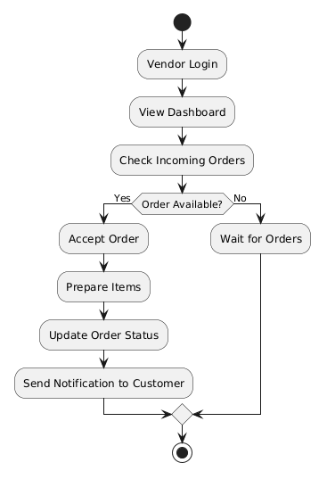
4.3.1.3 Vendor: Managing Product Inventory
Figure 4. 5: Vendor: Managing Product Inventory
This activity diagram illustrates the workflow for vendors in managing their product inventory within the system. The process begins when the vendor logs into the platform and opens the inventory management section. The vendor then decides whether to add a new product or update/delete an existing one. If adding a new product, the vendor enters the required product details such as name, price, description, and stock quantity. If updating or deleting an existing product, the vendor modifies the relevant product information accordingly. After completing the desired changes, the vendor saves the updates, and the system refreshes the database to store the latest inventory information. The process ends once the database has been successfully updated.
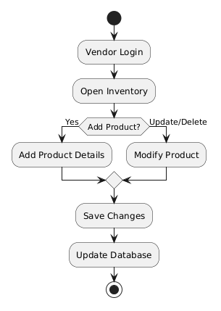
4.3.1.5 Vendor: Inventory Management
Figure 4. 6: Vendor: Inventory Management
This activity diagram illustrates the workflow for vendors to manage their product listings within the system. The process begins with a Vendor Login and navigating to Open Inventory, where a decision is made based on the vendor's intent. If adding a new item, the vendor proceeds to Add Product Details; if managing existing stock, they proceed to Modify Product. Both paths converge to Save Changes, followed by a system-level Update Database to finalize the entries before the process concludes at the final state.

4.4 Design Models
The design models provide a structured and visual representation of Smart Basket's system architecture and internal workflows. These models explain how different components interact, how data moves through the system, and how the system behaves in response to different events.

4.4.1 Sequence Diagram
Sequence diagrams illustrate how different components of the Smart Basket system communicate with each other to perform specific operations. They capture the interaction between system entities such as Customer, Vendor, Firebase modules, and the Notification System within particular workflows.
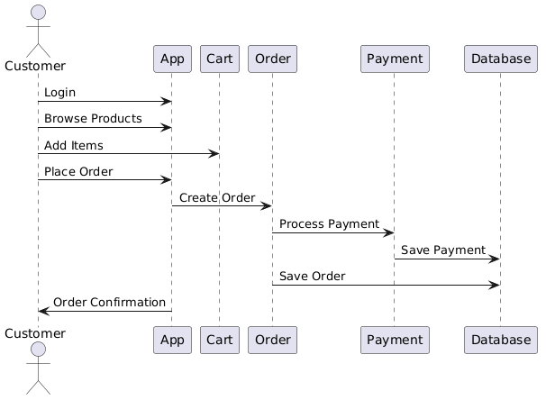
4.4.1.1 Customer: Order Placement and Payment Process
Figure 4. 7: Customer: Order Placement and Payment Process
This sequence diagram details the interaction between the customer and various system components during the purchasing lifecycle. The process begins with the Customer interacting with the App to Login and Browse Products, subsequently sending an Add Items request to the Cart. Once the customer initiates a Place Order, the App triggers the Order component to Create Order, which then coordinates with the Payment gateway to Process Payment. To ensure data integrity, the Payment and Order components perform Save Payment and Save Order actions to the Database, respectively, before the App finally returns an Order Confirmation back to the Customer.
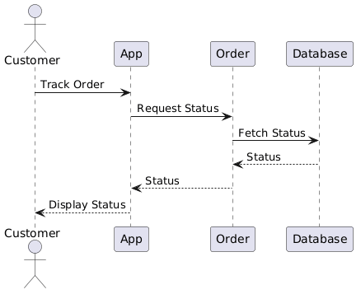
4.4.1.2 Customer: Order Tracking Process
Figure 4. 8: Customer: Order Tracking Process
This sequence diagram illustrates the communication flow for a customer checking the real-time progress of an existing purchase. The interaction begins when the Customer selects the Track Order option within the App, which subsequently sends a Request Status message to the Order management component. To provide accurate information, the Order component performs a Fetch Status query from the Database, which returns the current order data. This Status is then passed back through the Order component to the App, ultimately resulting in a Display Status message shown to the Customer.
4.4.1.3 Vendor: Order Acceptance and Management
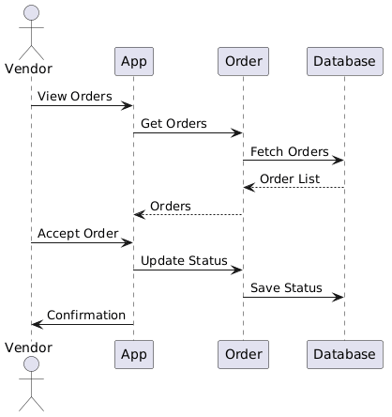
Figure 4. 9: Vendor: Order Acceptance and Management
This sequence diagram outlines the operational flow for a vendor managing incoming service or product requests. The process begins with the Vendor selecting View Orders on the App, which triggers a Get Orders request to the Order component. The Order component then performs a Fetch Orders operation from the Database, returning an Order List that is displayed to the vendor via the App. Once the vendor chooses to Accept Order, the App sends an Update Status command to the Order component, which then executes a Save Status action to the Database to record the change. Finally, the App provides a Confirmation message to the Vendor to complete the transaction.
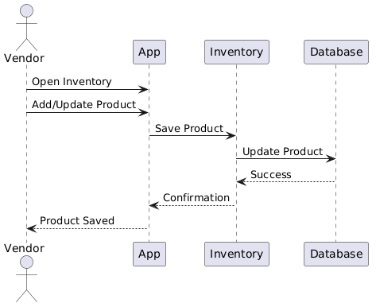
4.4.1.4 Vendor: Product Inventory Sequence
Figure 4. 10: Vendor: Product Inventory Sequence
This sequence diagram details the backend interactions for a vendor managing their digital storefront. The process initiates when the Vendor performs an Open Inventory action on the App, followed by an Add/Update Product request containing the new or modified item details. The App forwards a Save Product command to the Inventory management component, which communicates directly with the Database via an Update Product call. Upon receiving a Success signal from the Database, the Inventory component sends a Confirmation back to the App, which concludes the cycle by displaying a Product Saved notification to the Vendor.

4.4.2 Class Diagram
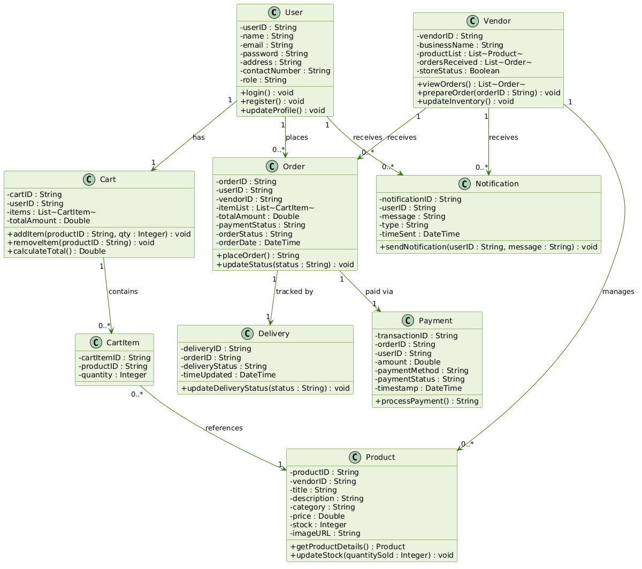
A class diagram is a static structure diagram in UML that represents the overall structure of Smart Basket by illustrating its core classes, attributes, methods, and the relationships between them. It is used to visualize the system architecture, support documentation, and guide implementation.

Figure 4. 11 : Smart Basket Class Diagram
This class diagram illustrates the structural architecture and relationships within the Smart Basket system. It centers around the User and Vendor classes, where a User manages a Cart containing multiple CartItems and places multiple Orders. Each Order is linked to a Payment for processing and a Delivery for logistics tracking. On the supply side, a Vendor manages a catalog of Products, which are referenced by CartItems during the shopping process. Both User and Vendor entities interact with the Notification class to receive system alerts. The diagram defines key attributes like price, stock, and orderStatus, alongside critical methods such as placeOrder (), processPayment (), and updateInventory (), ensuring a cohesive flow between consumer actions and vendor management.

Chapter 5
IMPLEMENTATION

5 Implementation
In the implementation phase of Smart Basket, a set of well-defined algorithms powers the core functionalities of the application. These algorithms enable accurate order management, real-time inventory updates, secure payment processing, and smooth interactions between customers, vendors, and the Firebase backend. Built using Flutter on the frontend and Firebase Cloud Functions on the backend, Smart Basket follows a modular architecture that ensures efficient grocery operations and a seamless experience for both customers and vendors.

5.1 Algorithm
The following subsections present the core algorithms implemented in Smart Basket. Each algorithm is described with its function signature, inputs, outputs, a description, and a detailed pseudocode walkthrough.

5.1.1 User Authentication (Login / Signup)
Function: authenticateUser(credentials)
Input: credentials (object) — email (String), password (String), role (String: 'customer' | 'vendor')
Output: authToken (String) and userProfile (object) or error (String)
Description:
This algorithm handles secure registration and login for two actor types in Smart Basket: Customer and Vendor. On signup, user data is validated and the password is hashed by Firebase Authentication before being stored. On login, Firebase verifies credentials and returns a session token. The Flutter app stores this token and attaches it to every subsequent Firebase request, ensuring only verified users can access protected features.
Pseudocode:
- Receive email, password, and role from the login/signup screen.
- Validate that all fields are non-empty and that the email format is correct.
- Query Firebase Authentication for a user matching the provided email.
- If no matching user found, return error: 'User not found.'
- If user found, Firebase verifies the provided password against the stored hash.
- If passwords do not match, return error: 'Incorrect password.'
- If authentication succeeds, Firebase returns a session token.
- Store the token in the Flutter app and redirect the user to their role-specific dashboard.

5.1.2 Add Item to Cart
Function: addItem(productID, qty)
Input: productID (String), qty (Integer)
Output: updatedCart (object) or error (String)
Description:
This algorithm allows a customer to add grocery items to their shopping cart. Before adding, the system checks if the product is already in the cart (in which case quantity is incremented) or if it is a new item. The cart total is recalculated after every change and synchronized with Firestore.
Pseudocode:
- Receive productID and qty from the product detail screen.
- Fetch the customer's current cart document from Firestore.
- Check if productID already exists in the cart items list.
- If exists, increment quantity by qty.
- If not exists, add a new cart item entry with productID and qty.
- Call calculateTotal() to recompute the cart total.
- Save the updated cart to Firestore and update local cache.
- Return the updated cart object to the Flutter UI.

5.1.3 Place Order
Function: placeOrder(userID, cartID, deliveryAddress, paymentMethod)
Input: userID (String), cartID (String), deliveryAddress (String), paymentMethod (String)
Output: orderConfirmation (object) or error (String)
Description:
This algorithm handles the order placement process in Smart Basket. The system verifies stock availability for all cart items, creates a unique order record in Firestore, triggers payment processing, and dispatches push notifications to both the customer and the vendor.
Pseudocode:
- Receive userID, cartID, deliveryAddress, and paymentMethod from the checkout screen.
- Fetch cart items from Firestore using cartID.
- Verify stock availability for each product in the cart.
- If any product is out of stock, return error: 'Item unavailable. Please update cart.'
- Generate a unique orderID.
- Create a new Order document in Firestore with status 'Pending'.
- Deduct stock quantities for ordered products in Firestore.
- Dispatch push notifications to Vendor and Customer via FCM.
- Return the orderConfirmation object with orderID, total amount, and estimated delivery.

5.1.4 Process Payment
Function: processPayment(orderID, paymentMethod, paymentDetails)
Input: orderID (String), paymentMethod (String: 'COD' | 'JazzCash' | 'EasyPaisa'), paymentDetails (object)
Output: paymentReceipt (object) or error (String)
Description:
This algorithm handles payment processing for customer orders. For COD, the order is flagged as 'Pending Payment'. For digital wallet payments, the system sends a payment request to the integrated gateway, verifies the transaction, updates the order payment status in Firestore, and records the transaction.
Pseudocode:
- Receive orderID, paymentMethod, and paymentDetails from the payment screen.
- If paymentMethod is COD, set paymentStatus to 'Pending' and return confirmation.
- If paymentMethod is digital wallet, send payment request to JazzCash/EasyPaisa API.
- Await payment gateway response.
- If response status is 'failed', return error: 'Payment unsuccessful. Please retry.'
- If response status is 'success', generate a unique transactionID.
- Save Payment record to Firestore with transactionID, amount, method, and timestamp.
- Update Order paymentStatus to 'Paid' in Firestore.
- Send payment confirmation notification to Customer and Vendor.
- Return paymentReceipt object to the Flutter UI.

5.1.5 Update Delivery Status
Function: updateDeliveryStatus(orderID, status)
Input: orderID (String), status (String: 'Accepted' | 'Packed' | 'Out for Delivery' | 'Delivered')
Output: success (Boolean) or error (String)

Description:
This algorithm allows vendors to update the delivery status of an order. Each status update is saved in Firestore and triggers a real-time push notification to the customer informing them of the latest order progress.
Pseudocode:
- Receive orderID and new status from the vendor panel.
- Validate that the new status is a valid state transition.
- Fetch the Order document from Firestore using orderID.
- Update the orderStatus field with the new status and record the timestamp.
- Save the updated Order document to Firestore.
- Dispatch a push notification to the Customer via FCM with the updated status.
- Return success confirmation to the Vendor Panel.

5.1.6 Manage Inventory
Function: updateProduct(vendorID, productID, productData)
Input: vendorID (String), productID (String), productData (object: title, price, stock, category, imageURL)
Output: success (Boolean) or error (String)
Description:
This algorithm allows vendors to add, update, or remove product listings from the inventory. All changes are validated and synchronized in real time with the customer-facing product catalog in Firestore.
Pseudocode:
- Receive vendorID, productID, and productData from the inventory management screen.
- Validate that required fields (title, price, stock) are non-empty and correctly formatted.
- Check if the productID already exists in Firestore.
- If exists, update the existing product document with new productData.
- If not exists, create a new product document with a generated productID.
- Save the product document to Firestore under the vendor's product collection.
- If stock falls below the threshold, trigger a low-stock alert notification to the Vendor.
- Return success confirmation to the Vendor Panel.

5.1.7 Send Push Notification
Function: sendNotification (userID, message, type)
Input: userID (String), message (String), type (String: 'order' | 'payment' | 'delivery' | 'promo')
Output: success (Boolean) or error (String)
Description:
This algorithm handles the dispatch of push notifications to customers and vendors via Firebase Cloud Messaging. Notifications are triggered by system events and include a message body, timestamp, and action type.
Pseudocode:
- Receive userID, message, and type from the triggering system event.
- Fetch the FCM device token for the target user from Firestore.
- If no token found, log the notification for in-app display and return.
- Build a notification payload with title, message body, timestamp, and action type.
- Send the payload to the user's device via Firebase Cloud Messaging API.
- Store the notification record in the Notifications collection in Firestore.
- Return success confirmation.

5.1.8 View Dashboard Reports
Function: getDashboardData(vendorID)
Input: vendorID (String)
Output: dashboardData (object) or error (String)
Description:
This algorithm retrieves vendor business performance data from Firestore and generates the analytics dashboard summary. It aggregates total sales, completed orders, pending deliveries, and top-selling products.
Pseudocode:
- Receive vendorID from the authenticated vendor session.
- Query Firestore for all orders linked to the vendorID.
- Calculate totalSales by summing totalAmount of all 'Paid' orders.
- Count completedOrders (status = 'Delivered') and pendingOrders (status != 'Delivered').
- Identify top 5 best-selling products by quantity sold.
- Compile dashboardData object with all computed metrics.
- Return dashboardData to the vendor panel dashboard screen.

5.2 External APIs

Table 5. 1: External APIs
Library / API | Purpose
Flutter SDK (Dart) | Cross-platform mobile UI framework for building the Customer App and Vendor Panel for Android and iOS.
Firebase Authentication | Secure user registration, login, session management, and role-based access control for customers and vendors.
Firebase Firestore | Real-time NoSQL cloud database for storing users, products, orders, carts, payments, and notifications.
Firebase Cloud Storage | Hosts and retrieves media files such as product images and vendor logos.
Firebase Cloud Messaging (FCM) | Enables push notifications for order status, payment confirmation, and promotional alerts.
Firebase Cloud Functions | Serverless backend operations including payment verification, stock updates, and scheduled tasks.
Google Maps API | Location-based services for delivery address confirmation and nearby store detection.
JazzCash / EasyPaisa APIs | Local digital wallet payment gateway integration for processing customer payments.

Table 5.1: lists the key libraries and APIs utilized in the MediBot project along with their specific roles in the system. Axios is used to manage communication between frontend components and backend APIs. Next.js API routes provide server-side functionality for handling appointments, credit management, authentication, and administrative operations. PostgreSQL serves as the primary database for storing user accounts, doctor profiles, availability schedules, consultation history, and credit transactions, while Prisma ORM simplifies database modeling and query execution.
Clerk Authentication is used for secure login, signup, and role-based access control for patients, doctors, and administrators. The Vonage Video API enables real-time video consultations with secure audio and video communication features. Payment gateway integration is used to support the credit-based booking model, allowing patients to purchase credits securely. Tailwind CSS and Shadcn UI are used to design responsive and modern dashboards, ensuring a consistent user experience across all modules. Additionally, email services such as Nodemailer are used to send appointment confirmations, doctor verification notifications, and payout alerts. The system is deployed on cloud infrastructure such as Vercel, ensuring scalability, performance, and accessibility.

5.3 User Interface
The Smart Basket mobile application is designed using a user-centered approach to ensure ease of use for both customers and vendors. The interface is modern, responsive, and intuitive, following Material Design 3 principles. Navigation is structured through a bottom navigation bar and categorized tabs, ensuring users can reach key features quickly. The app adapts to various screen sizes on Android and iOS devices using Flutter's responsive layout system.

5.3.1 Splash Screen

Figure 5. 1: Splash Screen
The Splash Screen displays the Smart Basket brand logo and application name with a green gradient background while the application initializes. No user interaction is required. The app automatically navigates to the Login screen after initialization is complete. This screen creates a clean and professional start-up experience that reinforces the brand identity.

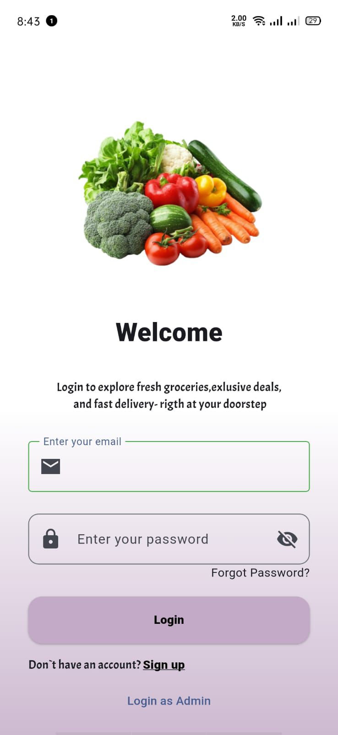
5.3.2 Login Screen

Figure 5. 2: Login Screen
The Login Screen allows existing users to securely log into their Smart Basket account. Users can enter their email address and password or choose to sign in via Google account. A 'Forgot Password' link allows users to trigger an email-based password reset. New users are directed to the Sign Up screen via a registration link. The system validates credentials through Firebase Authentication and redirects authenticated users to their respective dashboards.

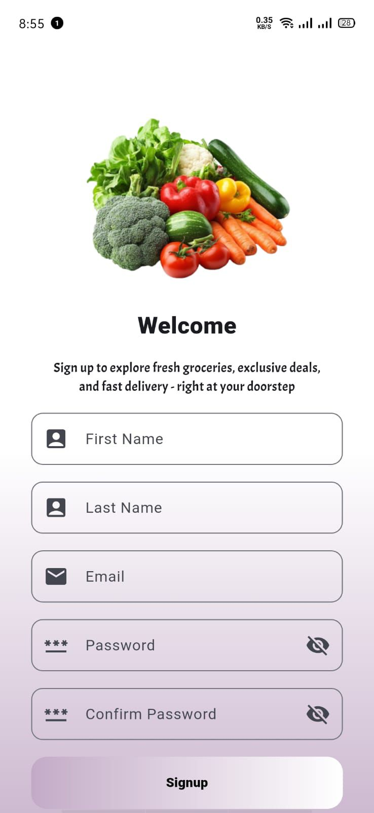
5.3.3 Sign-up Screen

Figure 5. 3: Sign-up screen
The Signup screen serves as the user registration portal for the application. It features a welcoming header, an image of fresh produce to highlight the service's focus on groceries, and a structured form for users to input their First Name, Last Name, Email, Password, and Confirm Password. Password visibility toggles are provided for security. Once the details are entered, the user taps the "Signup" button to create their account and begin using the service. This screen is designed to be user-friendly, ensuring a clear and efficient onboarding process for new customers.

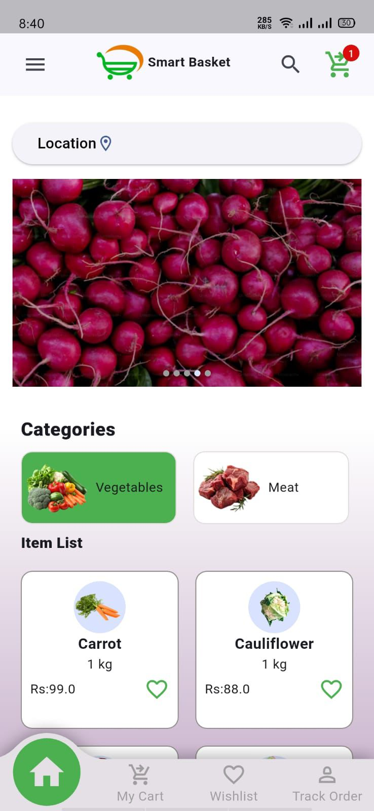
5.3.4 Home Screen

Figure 5. 4: Home Screen
The Home Screen serves as the main dashboard for customers after login. It displays a promotional banner slider, product categories (Vegetables, Meat, Dairy, Beverages, etc.), and product listing cards showing product name, image, price, and stock status. A search bar at the top allows customers to find specific products quickly. The bottom navigation bar provides quick access to the Home, Cart, Wishlist, and Profile sections. The cart badge updates in real time as items are added.

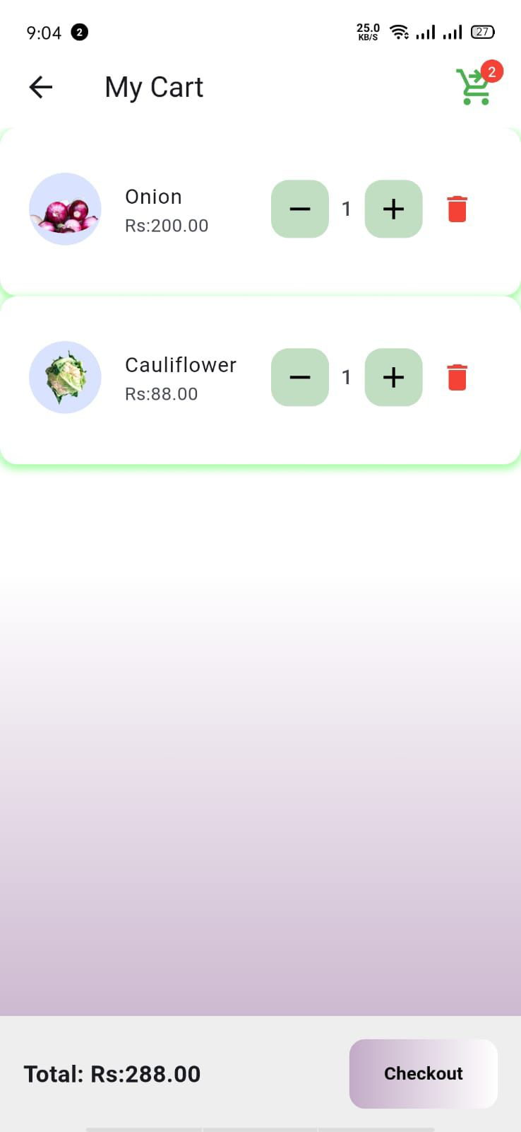
5.3.5 Cart Screen

Figure 5. 5: Cart Screen
The My Cart screen provides a clear overview of the items a user has selected for purchase. It lists each product, such as "Onion" and "Cauliflower," along with their individual prices, and includes interactive controls for each item to adjust quantities (+/- buttons) or remove items entirely using the trash icon. A cart icon in the top right corner indicates the total number of items, while the bottom section displays the calculated grand total and a "Checkout" button to proceed to the final payment steps. This screen is designed for transparency and ease of management, allowing users to review and finalize their order quickly.

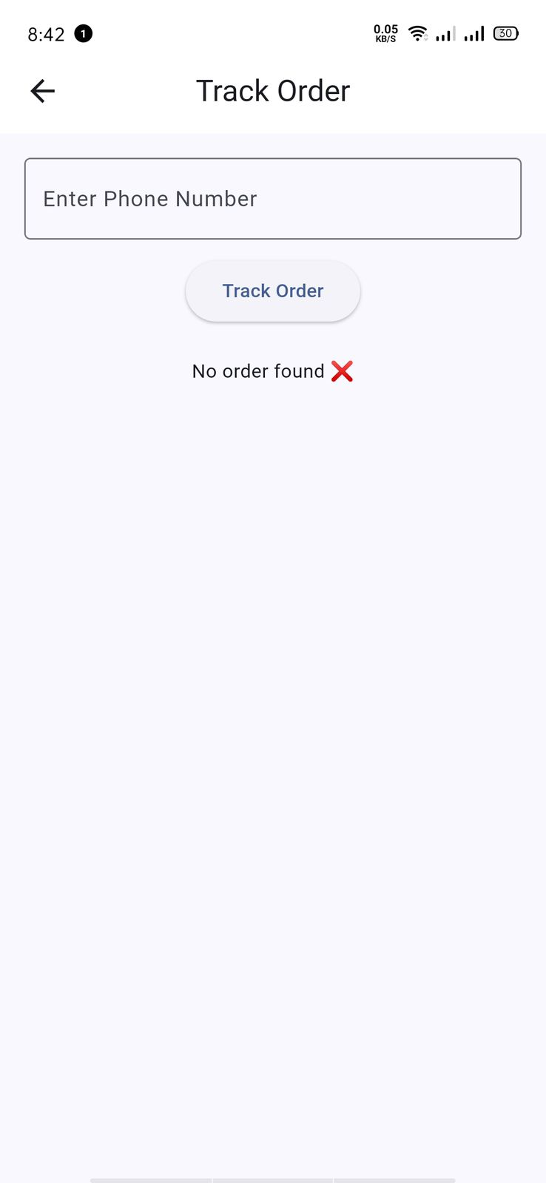
5.3.6 Tracking Screen

Figure 5. 6: Tracking Order Screen
The Track Order screen allows users to monitor the status of their purchases by entering their phone number into the provided input field. Once the number is submitted, the user taps the "Track Order" button to retrieve the latest shipping and delivery information. The screen currently displays an error state ("No order found" accompanied by an "X" icon), which provides clear feedback if the entered phone number does not correspond to an active order. This interface maintains a minimalist design to ensure the tracking process remains quick and intuitive for the user.

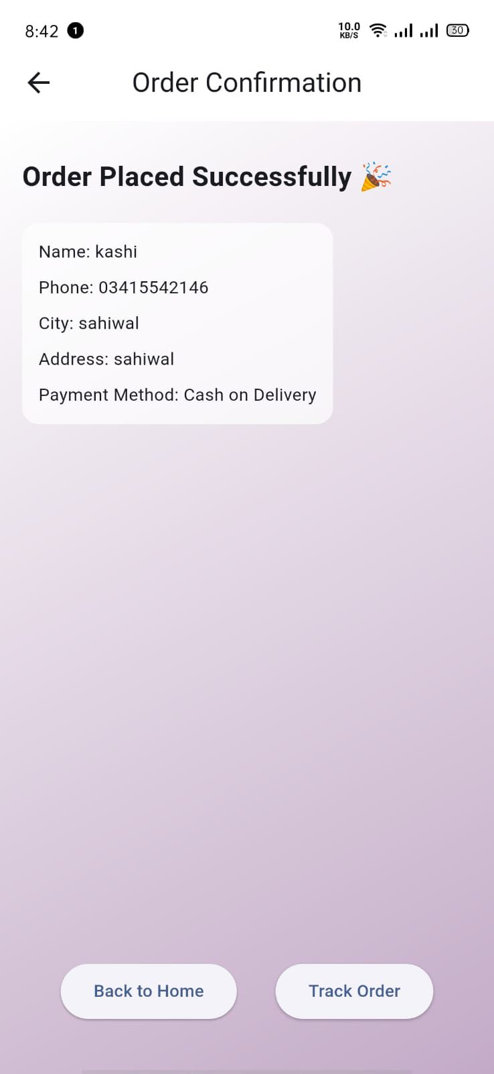
5.3.7 Order Confirmation

Figure 5. 7: Order Confirmation Screen
The Order Confirmation screen provides final verification that a user's transaction has been successfully completed. It features a celebratory header and a summary card displaying key order details, including the customer's name, phone number, city, delivery address, and the selected "Cash on Delivery" payment method. At the bottom, users are presented with two primary navigation options: "Back to Home" to continue shopping or "Track Order" to immediately view the status of their newly placed purchase. This screen provides the user with peace of mind by confirming that their order has been received and processed successfully.

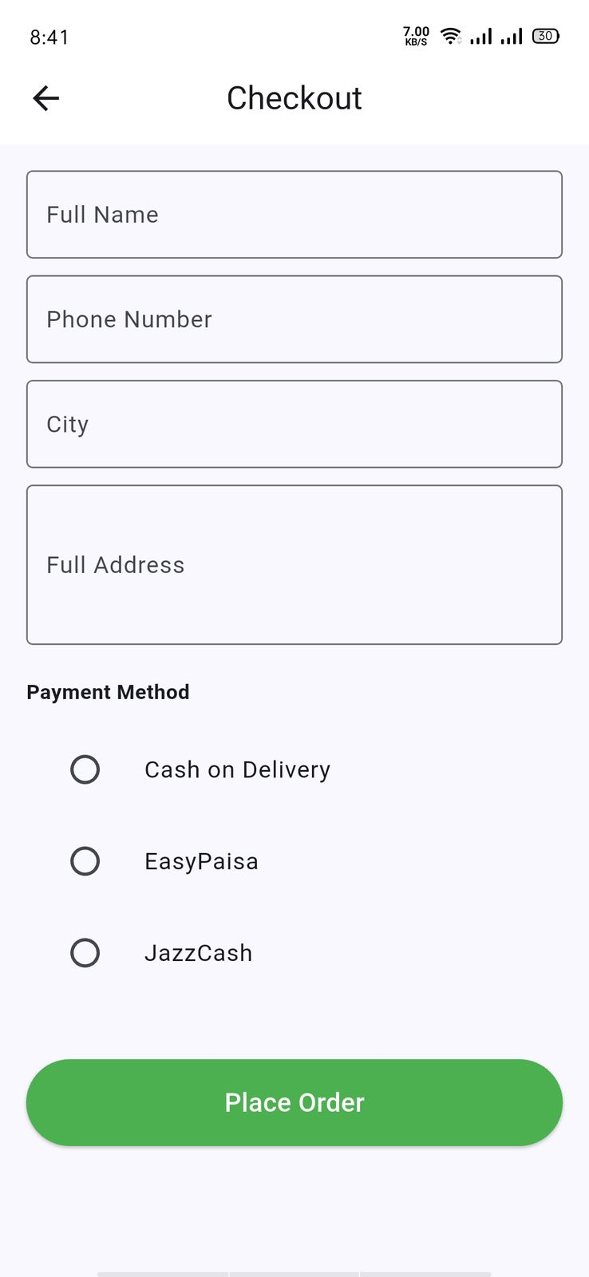
5.3.8 Checkout Screen

Figure 5. 8: Checkout Screen
The Checkout screen enables users to finalize their purchase by providing necessary delivery and payment details. It includes structured input fields for "Full Name," "Phone Number," "City," and "Full Address" to ensure accurate order routing. Below these fields, users can select their preferred payment method from options such as "Cash on Delivery," "EasyPaisa," or "JazzCash" using radio buttons. A prominent "Place Order" button at the bottom allows the user to complete the transaction. This interface is designed to be streamlined and efficient, ensuring a straightforward and secure transition from cart selection to order placement.

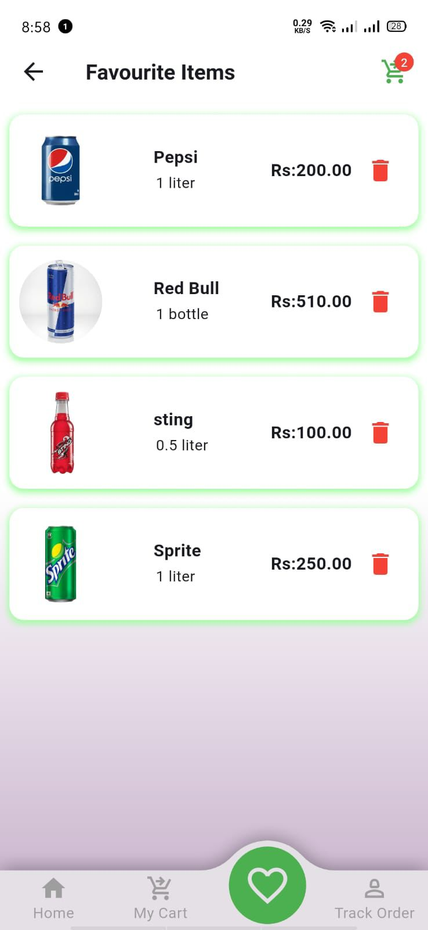
5.3.9 Favorite Items Screen

Figure 5. 9: Favorite Screen
The Favorite Items screen acts as a personalized wishlist, allowing users to save and easily access their preferred products. The interface presents a clean, scrollable list of items, such as various beverages, each displayed with its corresponding image, name, size, and price. A trash icon is conveniently placed next to each item, enabling users to quickly remove any product from their favorites list. At the bottom, a persistent navigation bar provides easy access to the main "Home," "My Cart," and "Track Order" sections, ensuring a seamless user experience while managing saved items

Chapter 6
TESTING AND EVALUATION

6 Testing and Evaluation
Testing plays a crucial role in ensuring that Smart Basket functions correctly, meets user expectations, and provides a secure and reliable grocery shopping experience. Testing was performed at multiple stages of development to identify bugs, validate workflows, and ensure smooth integration between system components. Through systematic testing, the application's performance, reliability, usability, and security were continuously evaluated. By adopting a structured testing strategy, Smart Basket ensures software quality, enhances usability, and eliminates major issues before deployment.

6.1.1 System Testing
System testing was performed after integrating all modules to verify overall system behavior. The testing focused on authentication, product browsing, cart management, order placement, payment processing, delivery tracking, and vendor operations.
Table 6. 1: System Testing Table
Test ID | Feature Tested | Description | Expected Result | Actual Result | Status
ST-01 | User Authentication | Test customer and vendor login/signup via email and Google | Successful login with role-based redirect | As expected | Pass
ST-02 | Product Browsing | Verify product listing and search functionality | Products displayed by category with correct details | As expected | Pass
ST-03 | Cart Management | Test adding, updating, and removing cart items | Cart total recalculated correctly in real time | As expected | Pass
ST-04 | Order Placement | Verify order creation with stock validation | Order saved to Firestore and vendor notified | As expected | Pass
ST-05 | Payment Processing | Test COD and digital wallet payment workflows | Payment recorded and order status updated to Paid | As expected | Pass
ST-06 | Order Tracking | Verify real-time order status updates | Status timeline updated and customer notified | As expected | Pass
ST-07 | Vendor Inventory Update | Test product add/update/delete in vendor panel | Inventory updated in Firestore and reflected in customer app | As expected | Pass
ST-08 | Push Notifications | Verify FCM notifications for order events | Notifications received on customer and vendor devices | As expected | Pass

6.1.2 Unit Testing
Unit testing involved testing individual modules independently to ensure each component performed correctly before integration. Smart Basket's critical modules were tested separately.
Table 6. 2: Unit Function Table
Module | Function | Expected Output | Actual Output | Status | Module
Authentication | authenticateUser() | Valid credentials return auth token | Auth token returned | Pass | Authentication
Cart Module | addItem(productID, qty) | Cart updated with new item and total recalculated | Cart updated correctly | Pass | Cart Module
Cart Module | calculateTotal() | Correct total calculated from cart items | Total computed correctly | Pass | Cart Module
Order Module | placeOrder() | Order document created in Firestore | Order created successfully | Pass | Order Module
Payment Module | processPayment() | Payment recorded and order status updated | Payment recorded correctly | Pass | Payment Module
Inventory Module | updateProduct() | Product data saved to Firestore | Product updated in Firestore | Pass | Inventory Module
Notification Module | sendNotification() | FCM notification dispatched to user | Notification delivered | Pass | Notification Module
Dashboard Module | getDashboardData() | Sales and order metrics returned | Metrics computed correctly | Pass | Dashboard Module

6.1.3 Functional Testing
Functional testing ensured that all use cases defined in the system requirements worked correctly for customers and vendors.
Table 6. 3: Functional Test Case Table
Test Case ID | Use Case | Input | Expected Output | Actual Output | Status
TC-01 | Register / Login | Valid email and password | Redirect to customer/vendor dashboard | Successful login | Pass
TC-02 | Browse Products | Category selection or search keyword | Matching products displayed | As expected | Pass
TC-03 | Place Order | Cart items, delivery address, payment method | Order confirmed with unique Order ID | As expected | Pass
TC-04 | Make Payment | JazzCash payment details | Payment recorded, order status Paid | As expected | Pass
TC-05 | Track Order | Active Order ID | Real-time status timeline displayed | As expected | Pass
TC-06 | Manage Inventory | Product name, price, stock update | Updated product visible in customer app | As expected | Pass
TC-07 | View Dashboard | Vendor credentials | Sales metrics and charts displayed | As expected | Pass

6.1.4 Integration Testing
Integration testing ensured smooth communication between interconnected modules such as authentication, cart management, order processing, payment handling, and push notifications.
Tested Integrations:
- Customer App ↔ Firebase Authentication ↔ Role-Based Dashboard
- Product Catalog ↔ Firestore ↔ Customer Cart
- Cart Module ↔ Order Management ↔ Payment Processing
- Order Status ↔ Delivery Module ↔ FCM Notification
- Vendor Inventory ↔ Customer Product Listings
Table 6. 4: Integration Testing Table
Integration ID | Modules Integrated | Expected Result | Actual Result | Status
IN-01 | Authentication & Role Dashboard | Customer/Vendor redirected to correct dashboard | As expected | Pass
IN-02 | Cart & Order Module | Order created from cart items with stock deduction | As expected | Pass
IN-03 | Order & Payment Module | Payment recorded and order status updated to Paid | As expected | Pass
IN-04 | Order Status & FCM Notification | Customer notified on each status change | As expected | Pass
IN-05 | Vendor Inventory & Customer Catalog | Product updates reflected in real time | As expected | Pass

6.2 Tools and Technologies
During the testing and evaluation phases, the following tools and frameworks were employed to ensure the MediBot Platform performed efficiently and accurately. Each tool played a significant role in either developing, testing, or validating specific system functionalities. Frontend and backend frameworks ensured smooth user interaction and data processing, while AI and database technologies supported smart recommendations and reliable data handling. Testing tools like Postman and GitHub enhanced quality assurance, version control, and collaboration throughout the process:
Table 6. 5: Tools and Technologies Table
 | Tool / Framework |  | Category |  | Purpose / Description
 | Flutter SDK |  | Frontend Framework |  | Builds cross-platform mobile UI for Customer App and Vendor Panel on Android and iOS.
 | Dart |  | Programming Language |  | Primary language used for Flutter application development.
 | Firebase Firestore |  | Database |  | Real-time NoSQL cloud database for storing all system data.
 | Firebase Authentication |  | Authentication |  | Secure login, signup, and role-based access control.
 | Firebase Cloud Messaging | Notification Service |  | Push notifications for order events, payment updates, and promotions.
Firebase Cloud Functions |  | Serverless Backend |  | Handles server-side logic including payment processing and stock updates.
Google Maps API |  | Location Services |  | Delivery address confirmation and store location detection.
Android Studio |  | IDE |  | Primary development environment for Flutter mobile development.
Postman |  | API Testing Tool |  | Tests Firebase Cloud Function endpoints and payment gateway APIs.

Table 6.2.1: lists tools used in development and testing. These technologies ensured reliability, scalability, and efficient testing.

6.3 Summary
The testing and evaluation phase successfully validated Smart Basket's reliability, usability, and performance. Through manual, unit, functional, and integration testing, all major functionalities were verified against the system requirements. The authentication system, product browsing, cart management, order placement, payment processing, delivery tracking, and vendor operations all performed correctly and reliably.
Minor interface issues discovered during manual testing were corrected to improve usability and user experience. Integration between modules such as order placement, payment processing, inventory updates, and push notification delivery worked seamlessly without data inconsistencies. Overall, the testing phase confirmed that Smart Basket is stable, secure, and ready for deployment. The system meets its project objectives by providing secure authentication, real-time grocery management, digital payment support, and a user-friendly cross-platform experience for both customers and vendors.

Chapter 7
CONCLUSION AND FUTURE WORK

7 Conclusion
The development of the Smart Basket grocery shopping platform successfully achieved its primary objective — to design and implement a modern, secure, and user-friendly mobile application that connects local grocery vendors with customers through a digital platform. The system bridges the operational gap between traditional grocery stores and digitally empowered consumers by integrating real-time inventory management, order processing, digital payment handling, and push notification delivery into a single, cohesive mobile application.
Throughout the project, strong emphasis was placed on usability, functionality, and scalability. The system architecture was designed using a modular MVVM approach, ensuring that each component — including user authentication, product management, cart handling, order processing, payment integration, notification delivery, and vendor reporting operates independently while integrating seamlessly with the overall system. This modular structure improved system maintainability, simplified testing, and supports future enhancements without disrupting existing functionality.
The user interface, built using Flutter with Material Design 3 principles, provides an intuitive and consistent experience for both customers and vendors across Android and iOS devices. The Firebase backend ensures real-time data synchronization, secure authentication, and scalable cloud infrastructure that can grow with the user base. The integration of Firebase Cloud Messaging delivers timely push notifications, while support for JazzCash and EasyPaisa payment gateways makes the platform accessible to a wide range of users in Pakistan's local retail market.
Comprehensive testing including manual testing, unit testing, functional testing, and integration testing confirmed that all system modules perform reliably. Each feature, from customer registration and product browsing to order placement, payment processing, delivery tracking, and vendor dashboard reporting, was validated against the defined system requirements. The integration between all modules proved to be stable, consistent, and efficient.
In conclusion, Smart Basket demonstrates how modern mobile technologies and cloud infrastructure can significantly improve digital accessibility in Pakistan's local grocery retail sector. The system automates grocery management processes, enables seamless digital transactions, and provides efficient workflow tools for both customers and vendors. Smart Basket fulfills its project objectives and establishes a solid foundation for future advancements in AI-assisted grocery recommendations, barcode scanning, and expanded payment gateway integration.

7.1 Future Work
While the current version of Smart Basket fulfills its core objectives, several enhancements can further improve functionality, scalability, and real-world usability:
- AI-Based Product Recommendations: Implementing machine learning models to analyze customer purchase history and browsing behavior, providing personalized product recommendations that improve the shopping experience and increase vendor sales.
- Barcode Scanning for Inventory: Integrating camera-based barcode scanning to allow vendors to quickly add or update product stock by scanning product barcodes, reducing manual data entry errors and improving inventory management efficiency.
- Real-Time Chat Between Customer and Vendor: Adding a secure in-app chat feature allowing customers to communicate directly with vendors for order-specific queries, product availability questions, and delivery coordination.
- Expanded Payment Gateway Integration: Integrating additional payment gateways including bank transfers and credit/debit card processing to provide a wider range of payment options beyond JazzCash and EasyPaisa.
- iOS App Store Deployment: Extending Smart Basket deployment to the Apple App Store to reach iOS users and expand the platform's customer base.
- Urdu Language Support: Adding Urdu language localization to make the application more accessible to a broader audience within Pakistan, particularly in areas where English literacy is limited.
- Advanced Analytics Dashboard: Enhancing the vendor reporting dashboard with advanced analytics including monthly revenue trends, customer retention rates, peak ordering times, and product category performance insights.
- Loyalty and Rewards System: Introducing a customer loyalty points system where users earn points on purchases that can be redeemed for discounts or free products, promoting customer retention and repeat orders.

Chapter 8
REFERENCE

8 References
[1] Google Firebase, "Firebase Documentation," 2024. [Online]. Available: https://firebase.google.com/docs
[2] Google Flutter, "Flutter Documentation," 2024. [Online]. Available: https://flutter.dev/docs
[3] Google Dart, "Dart Programming Language Documentation," 2024. [Online]. Available: https://dart.dev/guides
[4] Google, "Material Design 3 Guidelines," 2024. [Online]. Available: https://m3.material.io/
[5] Google Maps Platform, "Google Maps API Documentation," 2024. [Online]. Available: https://developers.google.com/maps/documentation
[6] JazzCash, "JazzCash Payment Gateway Documentation," 2024. [Online]. Available: https://developer.jazzcash.com.pk/
[7] Easypaisa, "Easypaisa Developer Integration Guide," 2024. [Online]. Available: https://easypaisa.com.pk/developers
[8] Kanungo, B., Flutter for Beginners, Packt Publishing, 2021.
[9] Patel, M., & Shah, S., 'Mobile Grocery Shopping Apps: Challenges and Opportunities', Journal of Mobile Computing, 2022.
[10] Ahmed, R. & Raza, K., 'Mobile Commerce and Small Retail Businesses in Developing Markets', International Journal of E-Commerce Research, 2021.
[11] Khan, A. et al., 'Real-Time Database Systems for Mobile Applications Using Firebase', IEEE Conference on Cloud Computing, 2022.
[12] Stack Overflow, "Developer Documentation and Technical Discussions," 2024. [Online]. Available: https://stackoverflow.com/
[13] UML.org, "Unified Modeling Language (UML) Specifications," 2024. [Online]. Available: https://www.uml.org/
[14] PlantUML, "PlantUML Diagram Tool Documentation," 2024. [Online]. Available: https://plantuml.com/
[15] GitHub, "GitHub Documentation," 2024. [Online]. Available: https://docs.github.com/

